Muscle | Origin | Insertion | Innervation | Action
Trapezius  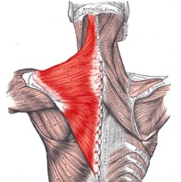 | External occipital protuberance  Superior nuchal line  Ligamentum nuchae  Spinous process of CVII-TXII | Upper fibres – lateral 1/3 clavicle  Middle fibres – acromion  Lower fibres – spine of scapula | CNXI – Spinal part of Accessory nerve | - Elevates the scapula  - Rotates the scapula during aBDduction of the humerus above horizontal  - Middle fibres retract scapula  - Lower fibres depress scapula
Latissimus Dorsi  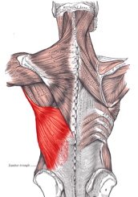 | T6-T12  Iliac Crest  Thoracolumbar fascia  Inferior 3 ribs | Bicipital groove (intertubercular sulcus) of the humerus | Thoracodorsal nerve  C6, C7, C8 | Extends, aDDucts and medially rotates the upper limb
Levator Scapuli Superioris | C1-C4 transverse processes | Medial border of the scapula | Dorsal scapular nerve (branch of the brachial plexus) | Elevates the scapula
Rhomboid Major (inferior)  Rhomboid Minor (superior) | T2-T5 vertebrae | Posterior surface of medial border of scapula | Dorsal scapular nerve  (C4, C5) | Elevates and retracts the scapula
 | C7-T1 | Posterior surface of medial border of scapula | Dorsal scapular nerve  (C4,C5) | Elevates and retracts the scapula
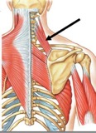

Rotator cuff muscles

Name | Meaning | Origin | Insertion | Nerve Supply | Action
Supraspinatus | Above spine of scapula | Medial 2/3rd of supraspinous fossa | Capsule of shoulder joint  +  Greater tubercule of the humerus  (most superior facet) | Suprascapular nerve  (C5, C6) | aBDuction of arm at glenohumeral joint
Infraspinatus | Below spine of scapula | Medial 2/3rd of infraspinous fossa | Greater tubercle of the humerus  (Lower down than supraspinatous) | Suprascapular nerve (C5,C6) | Lateral rotation at glenohumeral joint
Teres Minor  *under the lower border of the teres minor, the axillary nerve leaves the axilla to enter the posterior compartment which lies across the posterior surface of the humerus. | Minor rounded muscle | Lateral border of the scapula | Capsule of shoulder joint  +  Greater tubercle of the humerus  (Below insertion of the infraspinatus) | Axillary Nerve  (C5,C6)  supplies:  deltoid  teres minor  long head of triceps brachii | Lateral rotation at glenohumeral joint
Subscapularis | Muscle below the scapula | Subscapular fossa | Lesser tubercle of humerus | Upper and lower subscapular nerves (C5, C6, (C7)) | Medial rotation of arm at the glenohumeral joint

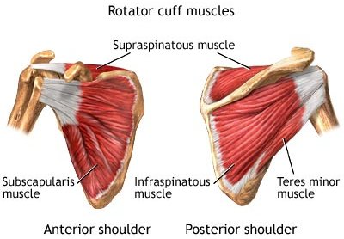

Name | Origin | Insertion | Nerve supply | Action
Deltoid muscle  (anterior, middle and posterior)  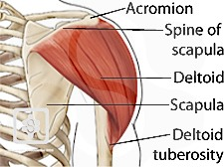 | Clavicle  Acromion  (bony process of the scapula)  Spine of scapula | Deltoid tuberosity of the humerus | Axillary nerve | Anterior fibres  Flex arm at the shoulder  Middle fibres  Major aBDuctor  (abducts the arm beyond the initial 15º done by the supraspinatus)  Posterior fibres  Extend arm at the shoulder
Teres Major  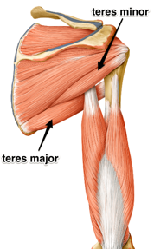  forms the inferior border of the quadrangular space – the ‘gap’ that the axillary nerve and the circumflex humeral artery pass through to reach the posterior scapula region | Posterior surface of the inferior surface of the scapula | Intertubecular/bicipital groove of the humerus | Lower subscapular nerve | aDDucts at shoulder  Medially rotates the arm
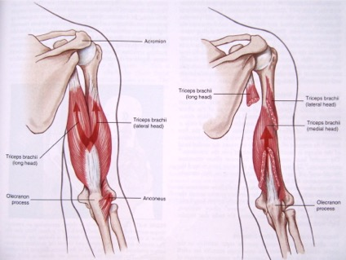

TRICEP MUSCLES
THE ONLY MUSCLE IN THE POSTERIOR COMPARTMENT
Three heads:

Long head
Origin – infraglenoid tubercle
It is the most medial part of the triceps in the upper arm

Lateral head
Origin- posterior part of the upper third of the humerus

Medial head
Lays deeper than the other two and requires that the other two heads are dissected away

All three heads combine to make one muscle and they converge on to a tendon

Actions:
- Extension of the arm at the elbow

Innervation:
- Radial nerve (C6,C7,C8 mainly C7)

Blood supply
- Profundi brachii
SESSION 2 – AXILLA AND BRACHIAL PLEXUS
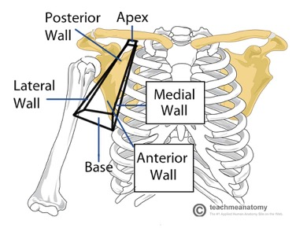
The axilla – space between the trunk and the upper arm.
It is pyramidal shape and its boundaries are:
- ANTERIOR: pectoralis major and minor
- POSTERIOR: subscapularis, teres major, lattisimus dorsi muscles
- LATERAL- upper end of the humerus, biceps brachii, coracobrachialis
- MEDIAL – serratous anterior muscle
- APEX – first rib medially with clavicle in front and radial behind
- BASE – skin and deep fascia extending between the chest wall and the arm

Axilla contains:
- Fat
- Lymph nodes – drain into the mammary gland (milk producing gland of a woman)
- Axillary artery – major artery supplying the upper limb
- Axillary vein – major venous drainage of the arm
- Brachial plexus – major nerve plexus supplying the limb

The Axillary sheath – A fibrous sheath that encloses the following structures:
- Axillary artery – lies deep to pectoralis major
- Axillary vein (medial to the artery)
- Brachial plexus

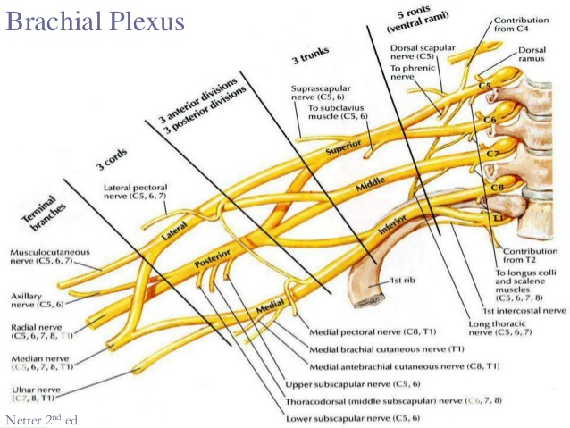

Read That Damn Cadavar Book

Branch | Root | Motor | Sensory
Musculocutaneous | C5-C7 | Muscles in the anterior compartment of the arm  FLEXORSSSSSS  - Biceps brachii  - Brachialis  - Coracobrachialis | Skin on lateral side of the forearm
Axillary | C5 , C6 | Deltoid, Teres Minor | Skin over upper lateral part of the arm
Radial | C5-C8, T1 | Muscles in the posterior compartment of the arm  EXTENSORSSSSS | Skin on the posterior aspects of the arm and forearm  Lower lateral surface of arm  Dorsal lateral surface of the hand
Median (lateral and medial root | (C5 sometimes)  C6-T1 | Anterior forearm  All muscles in the anterior compartment of the forearm  EXCEPT:  Flexor carpi ulnaris  Medial half of Flexor digitorum profundus  (supplies lateral half of flexor digitorum profundus)  Hand  Intrinsic muscles of the hand & skin of palm  LLOAF  LL. (lateral lumbricles)  O.A.F (three thenar muscles)  - Opponens pollicis  - aBductor pollicis brevis  - flexor pollicis brevis | Skin over palmar surface of the lateral three and one half digits
Ulnar | C8, T1 | Anterior forearm  - flexor capri ulnaris  - medial half of flexor digitorum profundus  Hand  All Intrinsic muscles of the hand & skin of palm  EXCEPT:  - Three thenar muscles  - Lateral lumbricles | Skin over palmar surface – medial one and a half digits  Skin over dorsal surface- one and a half digits
Thoracodorsal | C6-C8 | Lattisimus dorsi | -
Long thoracic nerve | C5-C7 | Lies on the superficial aspect of the serratus anterior and supplies this muscle
DERMATOMES - Sensory supply
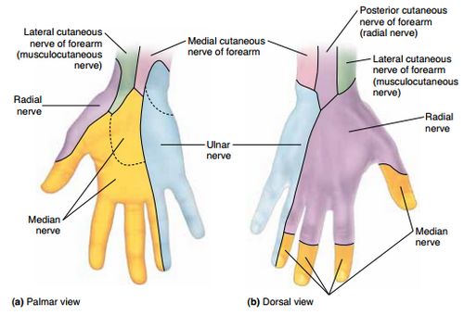
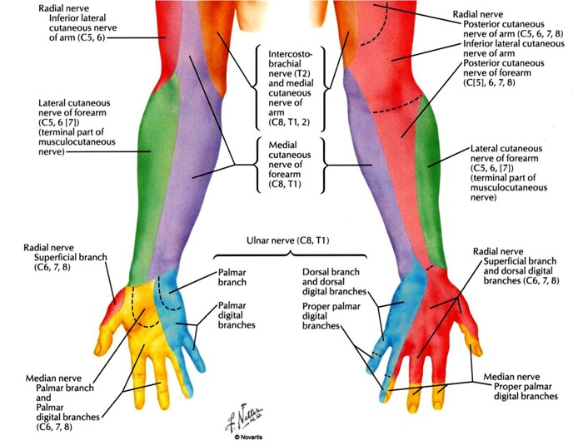

Axillary Artery
Blood vessel which conveys oxygenated blood to the lateral aspect of the thorax, the axilla and the upper limb. Its origin is at the lateral margin of the first rib before which it is called the subclavian artery

Anterior Rotator Cuff Muscle
- Subscapular Muscle
Origin ventral surface of the scapula
Insertion lesser tuberosity
MUSCLES IN THE ANTERIOR COMPARTMENT OF THE ARM
General Action - Flexors
Name | Origin | Insertion | Blood supply | Nerve supply | Action
Biceps brachii  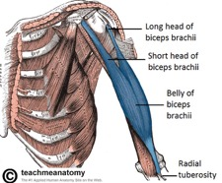 | Long head- supraglenoid tubercule of scapula  Short head – coracoid process of scapula | Inserted by tendon into the tuberosity of the radius | Brachial Artery | Musculocutaenous nerve (Roots C5-C7) | Supination of forearm  Flexor of arm at the elbow and shoulder joint
Brachialis  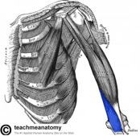 | Lower half of shaft of humerus | Coronoid process of ulna |  |  | Flexor at the elbow
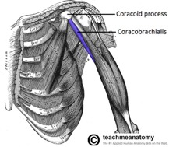  Coracobrachialis | Coracoid process of scapula  *the smallest muscle of three to come off of the coracoid process!  1) short head of biceps brachii  2) corocobrachialis  3) pectoralis minor | Medial side of humeral shaft |  |  | Flexor of arm at the shoulder joint (glenohumeral joint)

MUSCLES IN THE ANTERIOR COMPARTMENT OF THE ARM cont.
BBC: biceps brachii, brachialis, coracobrachialis
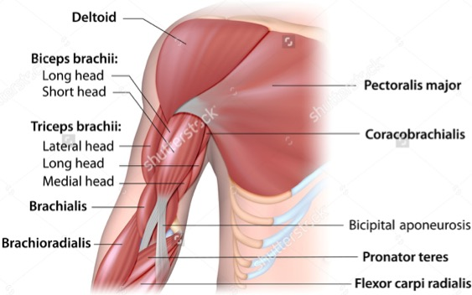

NOTE:
- Biceps brachii – crosses shoulder and elbow joint
*Note: bicipital aponeurosis is present I the cubital fossa and pays a role in separating superficial veins from the brachial artery and the median nerve

- Coracobrachialis – crosses shoulder joint
*deep to the short head of biceps brachii

- Brachialis – crosses elbow joint
*deep to the short and long head of biceps brachii

SESSION 3 – ANTERIOR COMPARTMENT OF THE FOREARM AND PALM OF THE HAND

General actions: FLEXION
Flexors of the wrist, and fingers
Pronation of the forearm

*NOTE: The median nerve supplies all muscles in the anterior forearm apart from*
- flexor carpi ulnaris
- flexor digitorum profundus

Name | Origin | Action | Innervation
Superficial
Pronator teres | Medial epicondyle of humerus | Pronation of forearm | Median nerve
Flexor carpi radialis |  | Flexor & aBduction of wrist
Palmaris longus |  | Flexion of the wrist
Flexor carpi ulnaris |  | Flexor & aBduction of wrist | Ulnar nerve
Intermediate
Flexor digitorum superficialis | Medial epicondyle of humerus  +  Ulna | Flexion of the 4 fingers  +  Flexion of the wrist | Median nerve
Deep
Flexor pollicus longus | Anterior surface of radius | Flexion of the thumb | Median nerve
Flexor digitorum profundus  ‘profundus = deep’ | Ulna | Flexion of the wrist + all interphalangeal joints | Median nerve (lateral half)  +  Ulnar nerve (medial half)
Pronator quadratus | Anterior surface of ulna | Pronation of the forearm | Median nerve
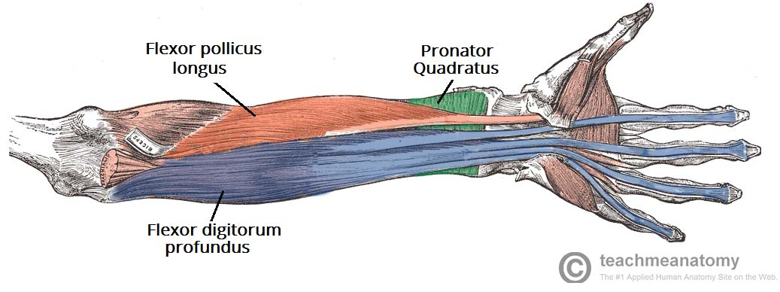
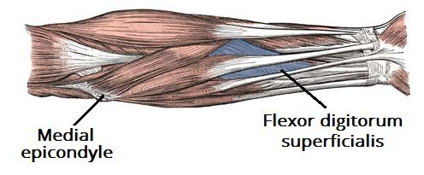
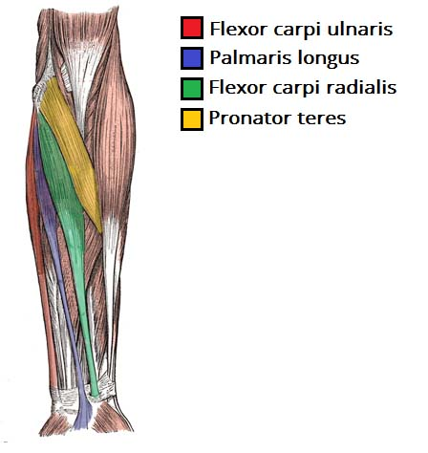

Notes

Movements of the thumb Bony prominences in the elbow
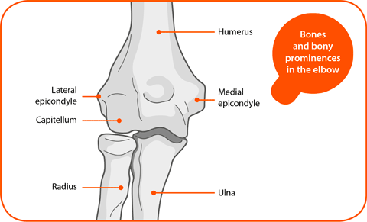
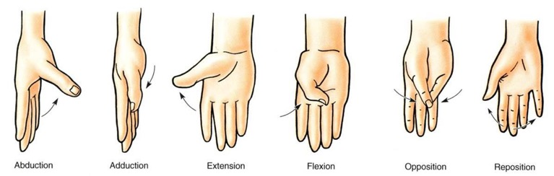

Epicondyles: these are the parts that stick out of the humerus. The medial one is more larger and is the common point of origin for the superficial flexor muscles (purple table)

Radius:
Humerus contribution: if asked ‘’ does it articulate with the humerus’ it does as it touches against the capitulum of the humerus but it does not contribute to the hinge joint of the elbow, it just helps with pronation and supination
Wrist joint contribution: articulates with the carpals at the wrist (proximal row i.e. scaphoid and lunate) ‘’radiocarpal joint’’

Ulnar:
Humerus contribution: the ulnar articulates with the trochlear and therefore makes an evident contribution to the hinge joint
Wrist joint contribution: the ulnar does not do much at the wrist
Interossesous membrane
Between the ulnar and radius is interosseous membrane, which provides an additional area for muscles to attach to. It also provides stability to the forearm.

It connects to the interosseous crest
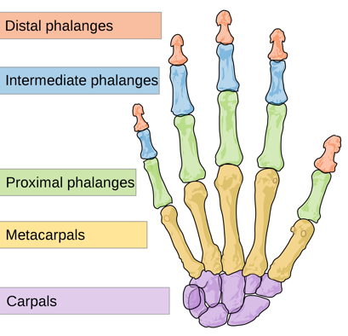
Pollox – proximal and distal phalanges
4 fingers – proximal, intermediate and distal phalanges

MP joint metacarpal phalangeal joint
IP joint interphalangeal joint

Radius - thumb side
Ulnar - opposite side to the thumb

Extrinsic muscles of the hand origin is outside of the hand
Intrinsic muscles of the hand origin and insertion are on the inside of the hand

Carpal Bones
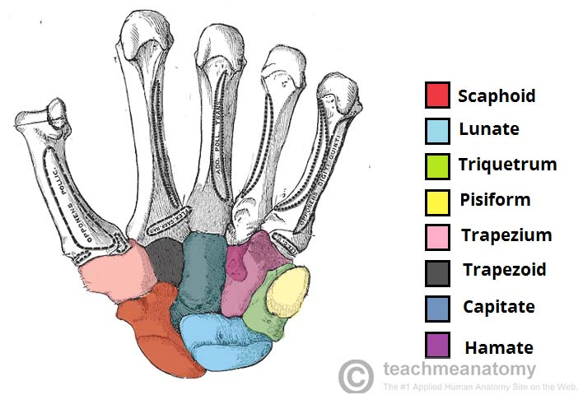
Some Lovers Try Positions That They Cannot Handle

Proximal row (left to right)
Scaphoid (thumb side)
Lunate
Triquetrum
Pisiform (this is the pivital bone on the wrist, only seen from palmar aspect)

Distal row (left to right)
TrapeziUM (for the thUMb)
Trapezoid
Capitate
Hamate

The cubital fossa

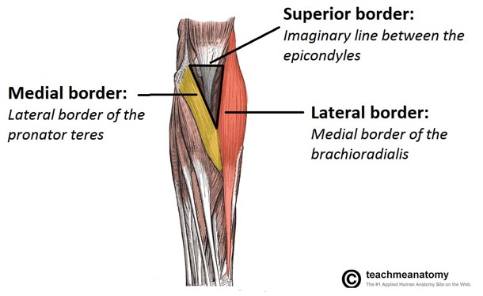

Boundaries
- Lateral border – The medial border of the brachioradialis muscle
- Medial border The lateral border of the pronator teres muscle
- Superior border– An imaginary line between the epicondyles of the humerus.

Clinical: Superficial veins are usually used here for intravenous injections.

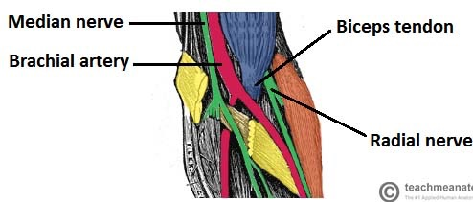

Contents

-Biceps tendon
-Radial nerve
-Median nerve
Leaves the cubital fossa by going through the pronator teres (between the superficial and deep head)
-Brachial artery
Bifurcates into the radial and ulnar arteries at the apex of the cubital fossa

Palm of the Hand
- Palmar fascia lies immediately deep to the skin of the palm and extends from the flexor retinaculum of the wrist and and is attached to the flexor sheath of each finger.
- In manual workers, the fascia can progressively scar leading to shortening of the fascia which pulls the finger into flexion

Carpal Tunnel Syndrome

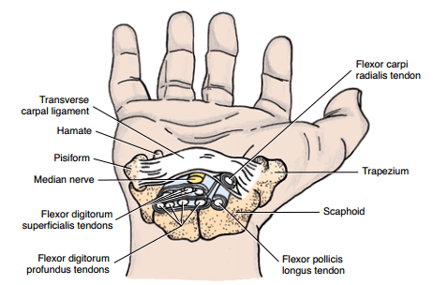
Carpel tunnel: a space between the flexor retinaculum of the wrist and the carpal bones of the wrist.
Contains:
- flexor superficialis/profundus tendons
- flexor pollicus longus tendon
- flexor carpi radialis tendon
- median nerve

Swelling of the tendons or arthritis affecting joints of the carpal bones can increase pressure in the tunnel therefore compressing the median nerve.

This leads to pain and diminished sensation on the skin along the distribution of the median nerve as well as weakness of the thenar muscles, which are also supplied by the median nerve.

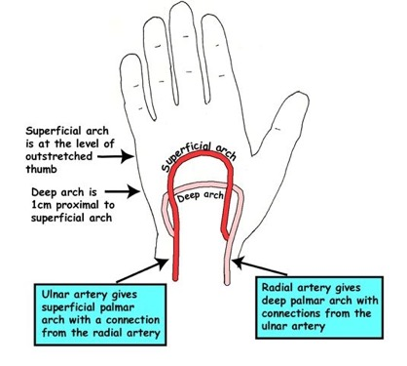
The ulnar nerve lies superficial to the retinaculum and is therefore not affected

The superficial palmar arch – formed predominanty by the ulnar artery
Represents the termination of the ulnar artery with a small contribution from the radial artery. It is deep to the palmer fascia over the tendons and nerves to the fingers

The deep palmar arch – formed predominantly by terminal part of the radial artery
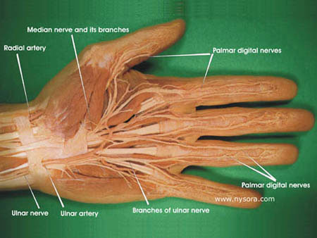
Median and Ulnar nerves

- Both supply intrinsic muscles of the hand and the skin of the palm of the hand
- Palmar digital branches – wind round the fingers to supply the skin on the dorsum of the terminal phalanges
- Palmar cutaneous branches of the ulna and median nerve
Supply the skin on the palm of the hand
In injuries of the median or ulnar nerves at the wrist, these palmar branches may escape damage and hence sensation in the palm of the hand may not be affected.
SENSATION OF THE PALM OF THE FINGERS WILL BE AFFECTED.

Lumbrical Muscles
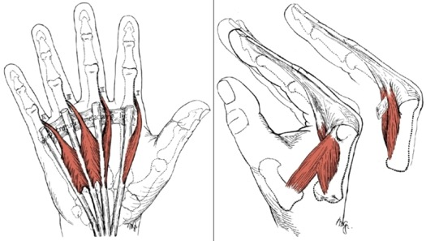
- 4 lumbrical muscles, one for each finger
- Origin: flexor digitorum profundus tendon crosses the metacarpophalangeal joint Insertion: dorsal digital expansion at the back of the finger
Action: simultaneously flex the metacarpophalangeal and extend the interphalangeal joints

Innervation:
Two lateral lumbricals: median nerve
Two medial lumbricals: ulnar nerve

The Thenar Muscles
Muscles are important in producing grip or pincer’s grip as in holding a pen.

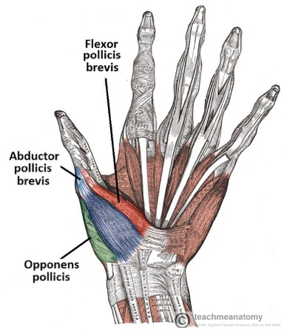
- opponens pollicis
- aBductor pollicis brevis (longus is in the posterior aspect of the arm on the deep layer)
- flexor pollicis brevis

Innervation: Median nerve

- ADductor pollicis
This is located more medially

Innervation: Ulnar nerve

The Hypothenar Muscles
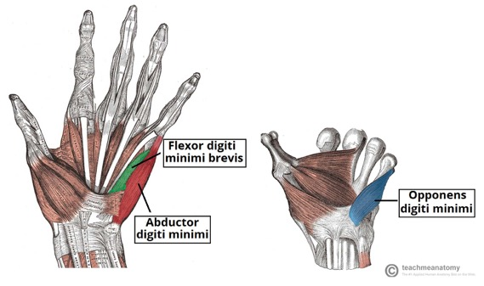
- Opponens digiti minimi
- aBductor digiti minimi
- flexor digiti minimi

Innervation: ulnar nerve

Insertions of the flexor tendons

Flexor digitorum superficialis
- tendon splits to be attached to each side of the middle phalanx.

Flexor digitorum profundus
- tendon passes between the gap in the superficialis tendon to insert into the terminal phalanx

Flexor pollicus longus
- tendon inserts to the base of the terminal phalanx of the thumb

* tendons are held on to the front of the finger by the fibrous flexor sheath

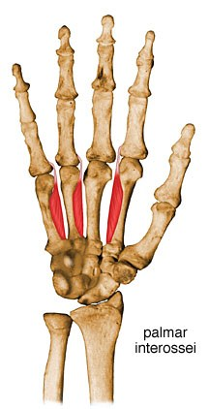
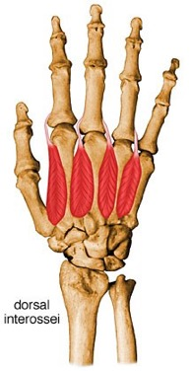
Interossei muscles
Lie between the metacarpal bones

3 Palmar interossei aDduction of fingers by moving them towards the middle finger
‘’ 3 to me, PAD = palmar, aDduction’

4 Dorsal interossei aBductors of the fingers by moving them towards the middle finger
‘’ 4 to the floor, DAB = dorsal aBduction’

Innervation: ulnar nerve

SESSION 4: POSTERIOR FOREARM, DORSUM OF HAND AND JOINTS OF UPPER LIMB
Note: no tendons here insert into the phalanges. They inset into the base of the sheet of connective tissue.
General Action: Extension

Name | Origin | Insertion | Innervation | Action
Superficial (5)
Extensor carpi radialis longus  Extensor carpi radialis brevis | Back of lateral epicondyle of humerus | 2nd and 3rd metacarpal bones | Radial nerve  *brachioradialis is supplied by a branch of the radial nerve just above the elbow | Extension and aBduction at the wrist
Extensor digitorum |  | Splits into 4 + inserts into extensor hood each finger |  | Extends fingers 2-5
Extensor digiti minimi |  | Into extensor hood of each finger |  | Extends little finger
Extensor carpi ulnaris |  | 5th metacarpal bone |  | Extension and aDduction
Deep (4)
Extensor pollicis longus |  |  | Radial nerve | Extends the thumb
Extensor pollicis brevis |  |  |  | Extends the thumb
Abductor pollicis longus  *brevis is in the thenar group* |  |  |  | aBducts the thumb
Extensor indicis |  |  |  | Extention of the index finger
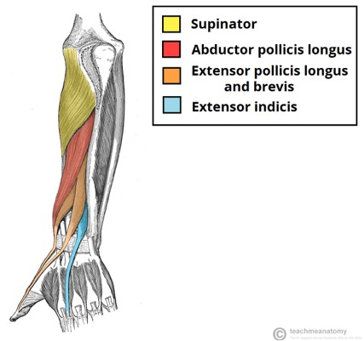
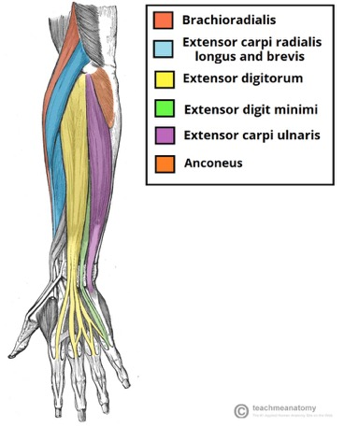

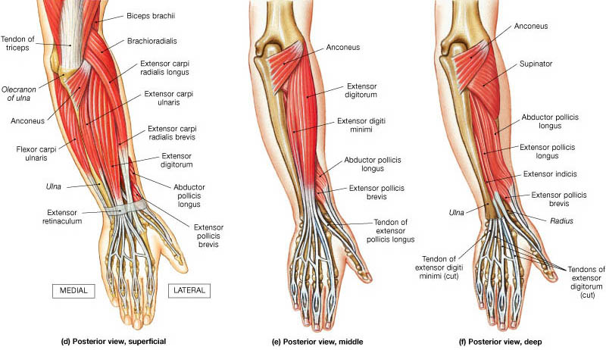

Supinator
Does not really belong to the superficial or the deep layers

Origin lateral epicondyle of humerus
Insertion lateral surface and posterior border of radius
Action: supinates the forearm

Brachioradialis

Origin proximal aspect of the lateral supracondylar ridge of the humerus
Insertion distal end of the radius
Action: flexion at the elbow
* think of the awkward hand movement izzie was doing! (think of someones hand in a sling being the original position and then the forearm moves upwards from there)
Clinical relevance

Wrist drop
- Paralysis of the radial nerve above the elbow will paralyse all the extensors of the wrist. The flexors of the wrist will pull the wrist into a flexed position.

Anatomical stuff box
*NOTE: THESE TERMS ARE USED IN THE CONTEXT OF THE ANATOMICAL POSITION WHERE THE FOREARM IS SUPINATED.

- Anterior/lateral (radial) border
Extensor pollicis brevis
Abductor pollicis longus

- Posterior/medial (ulnar) border
Extensor pollicis longus

The radial artery lies in it and the cephalic vein crosses it. After a fall on the outstretched hand, tenderness in the anatomical stuff box is suggestive of a fracture of the scaphoid bone. The whole bone is supplied by a single artery which enters the one from the distal end. If the scaphoid fractures, the proximal end of the bone may be disconnected from the blood supply and will undergo ‘avascular necrosis’.
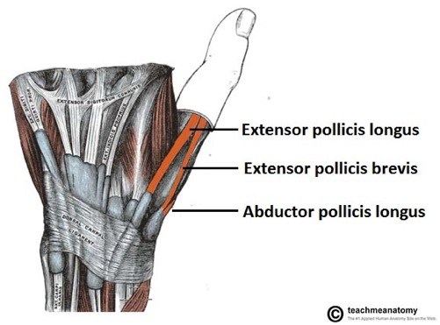
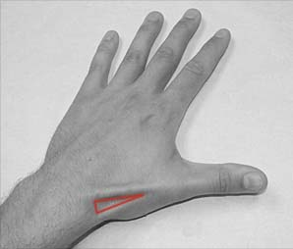

The extensor expansion
At the wrist, the extensor digitorum gives rise to four tendons which supplies digits 2-5. Each slip forms an expanded hood over the dorsum of the digit. The expansion is attached to the base of proximal phalanx before dividing into a central and two marginal slips.
- central slip is inserted to the base of the middle phalanx
- marginal slips unite together and inserts into the base of the distal phalanx

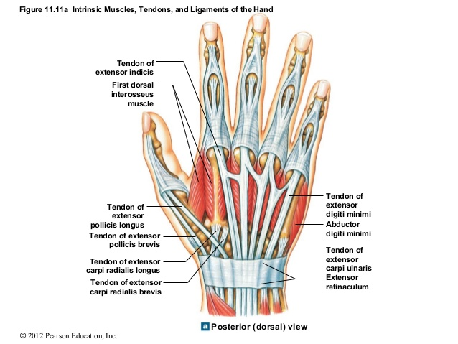

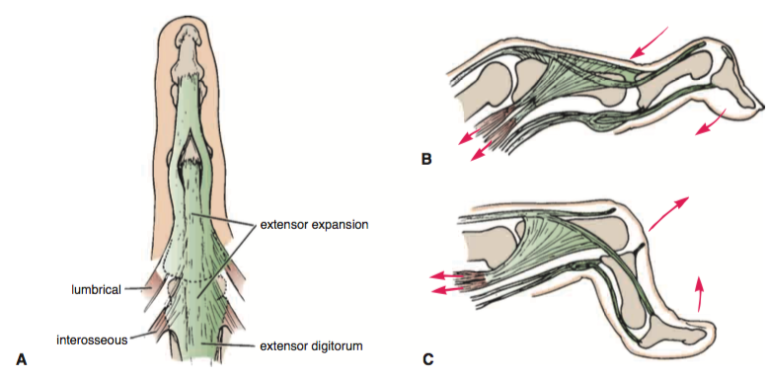

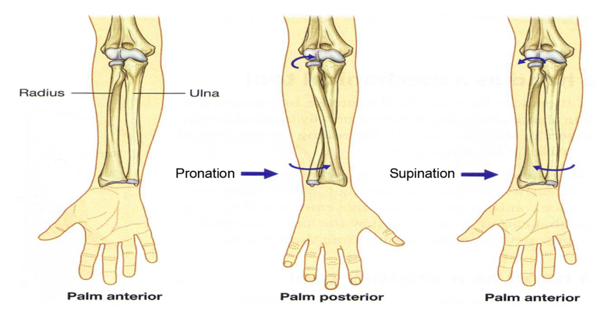
The joints of the upper limb

Joints of the elbow
Flexion and extension movements of the forearm take place at the elbow joint.

Main flexors: brachialis, biceps and brachioradialis
Common flexor origin– medial epicondyle

Main extensors: triceps
Common extensor origin – lateral epicondyle

At the radio-ulnar joints:
Pronation
- The radius moves inwards. Pronation is produced by the pronator teres and the pronator quadratus

Supination
- The radius moves outwards

- In the flexed position of the elbow, biceps acts as a powerful supinator.
- When the elbow is extended, supinator is responsible for supination although it is weak

Humerus
- Medial and lateral epicondyles huemerus
- Capitulum and trochlea of the humerus (radius articulates with the capitulum and the trochlea fits into the trochlear notch of the ulna)
- Cornoid fossa of the humerus
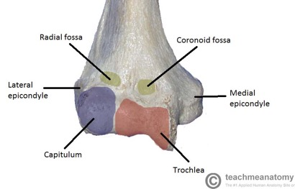
Ulnar nerve
Passes into the forearm along the posterior aspect of the medial epicondyle
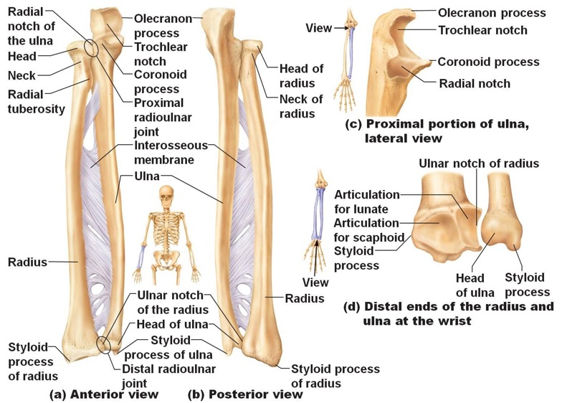
*Important points
Radius
Head and neck of radius
Tuberosity of radius

Ulna
Cornoid and olecranon process of the ulna
Trochlear notch on the ulna

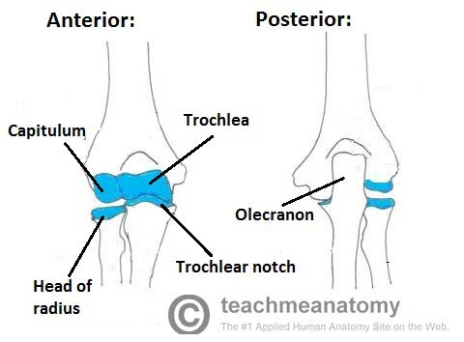
In the elbow joint:
Radius articulates with the capitulum of the humerus
Humerus fits into the trochlear notch of the ulnar

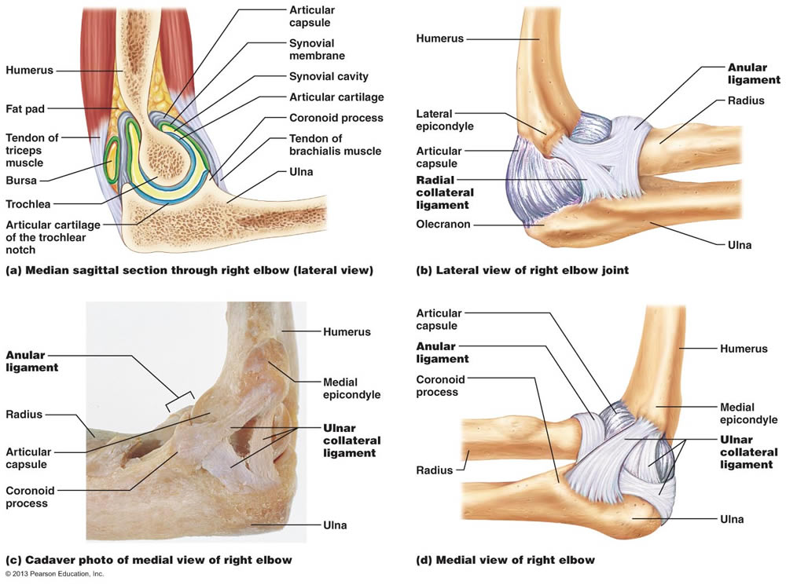

The elbow joint is a synovial joint.
- Like all synovial joints, the elbow joint has a capsule enclosing the joint which strengthens the joint.
- The joint capsule is thicken medially and laterally to form collateral ligaments which stabilise the flexing and extending motion of the arm.
- Radial collateral ligament: found on the lateral side of the joint extending from the lateral epicondyle and blending in with the anular ligament
- Ulnar collateral ligament: originates from the medial epicondyle and olecranon of the ulnar
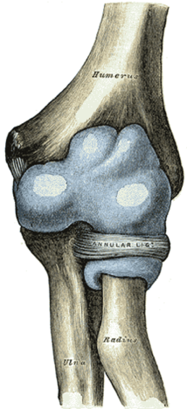
Annular ligament:
The annular ligament is a strong band of fibre that encircles the head and neck of the radius and retains it in contact with the radial notch of the ulna.

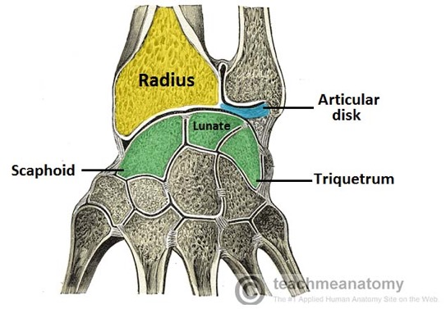
The Wrist Joint

At the wrist joint, the scaphoid, lunate and triquetral bones articulate proximally with the distal end of the radius.
The triangular fibrocartilage separates the wrist joint from the inferior radioulnar jpint

SESSION 5: THE LOWER LIMB

Quick overview…

Compartment | Muscles | Action | Innervation
Anterior | Iliopsoas  Different action, look below  Quadriceps femoris:  - Vastus lateralis  - Vastus intermedialis  - Vastus medialis  - Rectus femoris  Sartorius  Pectineus*  this compartment in terms of nerve supply | Flexion of thigh at the hip  Main action – extension of the leg at the knee | Femoral nerve  (L2-L4)
Medial | aDductors magnus  aDductor longus  aDductor brevis  obturator externus*  gracialis | Hip aDductors | Obturator nerve (Lumbar plexus)  Blood supply : obturator artery
Posterior | Biceps femoris  Semitendinosus  Semimembranosus | Extend at the hip  Flex at the knee | Sciatic nerve (L4-L3)

Lower limb: Anterior compartment of the thigh

General Action: extension of the leg at the knee
Nerve supply: femoral nerve
Blood supply: femoral artery

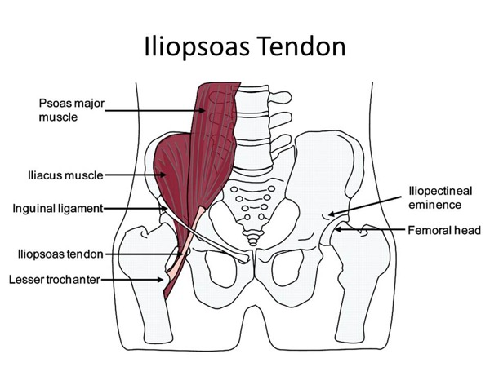
Iliopsoas
Consists of two muscles:
- Psoas major
- Iliacus

Unlike the other anterior thigh muscles, it does not extend the leg at the knee

Origins
Psoas major: lumbar vertebrae
Iliacus – iliac fossa of the pelvis

Insertions
Lesser trochanter of the femur

Actions
Flexes the lower limb at the hip joint and assists in lateral rotation at the hip joint

Innervation
Psoas major: anterior rami of L1-3
Iliacus: femoral nerve
Muscle | Origin | Insertion | Action | Innervation + Blood Supply
Quadriceps femoris
Rectus femoris | Femur | Patella via the quadriceps femoris tendon | -Flexes at leg and hip joint  -Extension of leg at the knee  * only muscle of quadriceps to cross both the hip and knee joint | Femoral nerve  Femoral artery
Vastus lateralis | Greater tronchanter & lateral lip of linea aspera |  | Extension of leg at the knee + stabilises patella | Femoral nerve  Femoral artery
Vastus intermedius | Anterior and lateral surface of femoral shaft |  | Extension of leg at the knee + stabilises the patella | Femoral nerve  Femoral artery
Vastus medialis | Intertronchanteric line and medial lip of the linea aspera |  | Extension of leg at the knee + stabilises the patella | Femoral nerve  Femoral artery
Sartorius (located superficially)
- | ASIS | Superior medial surface of tibia | Hip joint: flexor, aBductor, lateral rotator  Knee joint: flexor | Femoral nerve
Pectineus
- |  |  | aDuction and flexion at the hip joint | Femoral nerve
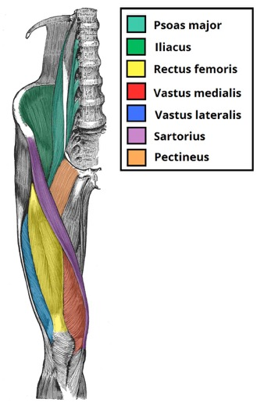
Note:
Ligaments: attach bones to bones
Tendons: muscles to bones

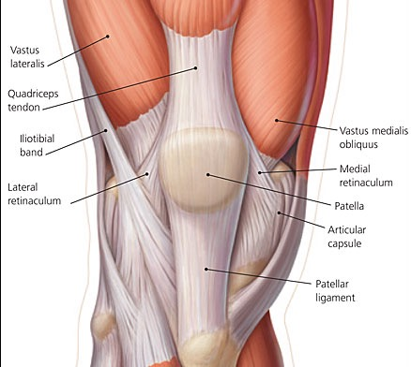
Quadriceps Femoris:
- Consists of four individual muscles, three vastus muscles and the rectus femoris
(check table)
- The muscles that form quadriceps femoris distally attach to the patella via the
patella tendon/quadriceps tendon (both the same thing)

Patella
- Ligamentum patella/Patella ligament:
Connected to the lower end of the patella and attaches into the tibial tuberosity

---------------------------------------------------------------------------------------------------------------------------------------------------------------------------------------------
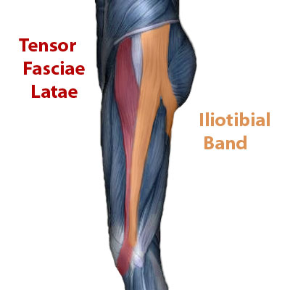
Tensor Fascia lata & iliotibial traxt

Fascia lata runs from the iliac crest and inserts into the tibia
Iliotibial tract a longitudinal fibrous reinforcement of the fascia latae

Actions:
Extend, aBduct and laterally rotate the hip

Lower limb: Medial Compartment of the Thigh

General Action: aDduction at the hip
Nerve innervation: obturator nerve
Blood supply: obturator artery

Muscle | Origin | Insertion | Action | Innervation
ADductor longus | Pubis | Linea aspera of the femur | aDuction and medial roation of the thigh | Obturator nerve  L2-L4
ADductor brevis  *lies underneath adductor longus and lies between the anterior and posterior divisions of the obturator nerve | Body of pubis and inferior pubic rami | Linea aspera of the femur | aDduction of the thigh | Obturator nerve  L2-L4
ADductor magnus  *largest muscle in the compartment and lies posteriorly to the other muscles | - aDuctor part  inferior rami of the piubis  - Hamstring part  Ischeal tuberosity | - aDuctor part  linear aspera of the femur  - Hamstring part  Adductor tubercle | aDuction of thigh  aDductor compartment: flexes thigh too  hamstring compartment: extends thigh too | Obturator nerve  L2-L4
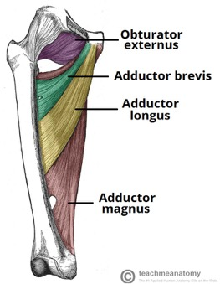

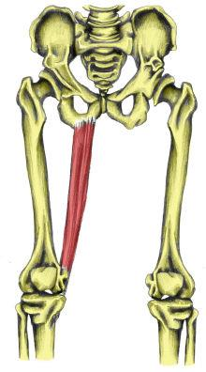
Gracilis
This is the most superficial and medial in this compartment. It crosses at both the hip and knee joint

Origin: inferior rami of the pubis and body of the pubis
Insertion: medial surface of the tibia

Action: aDuction of thigh at the hip, flexion of the leg at the knee

Innervation: Obturator nerve (L2-L4)

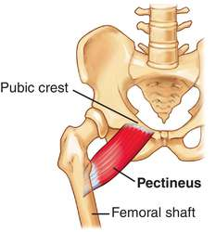
Pectineus muscle

Origin – pectineal line on the anterior surface of the pelvis
Insertion – below the lesser trochanter of the femur

Actions – aDdction and flexion at the hip joint
Innervation – Femoral nerve. May also receive a branch from the obturator nerve

The adductor (sub-sartorial) canal
- You can find the opening to the sub-sartorial canal deep to the Sartorius muscle.
- It extends from the apex of the femoral triangle and ends just above the knee at the adductor canal

Contents:
- Saphenous nerve: a large superficial vein which overlays the femoral triangle. The position of the long saphenous vein is constant and it the primary site for varicose veins and can be used in cardiac and limb bypass surgery.
- Femoral artery
- Femoral vein
- Lymphatic and loose connective tissue

The femoral artery and vein follow the sub-sartorial canal to where they pass through adductor magnus into the popliteal fossa at the back of the knee.

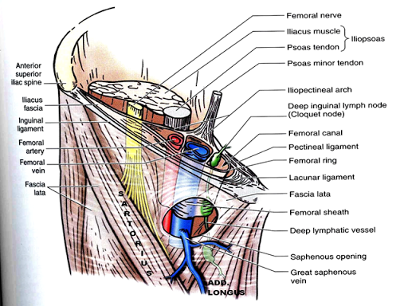
Femoral triangle
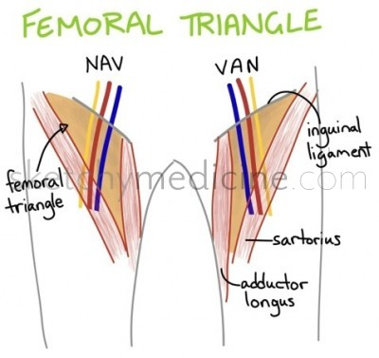
Contents:
- Femoral nerve
- Femoral artery
- Femoral vein
- Lymph canal
- The great saphenous vein drains into the femoral vein within the triangle

Way to remember content:
NAVEL
Nerve
Artery
Vein
Empty space
Lymph canal

Order of vessels:
NAV Y VAN
Vein near vagina!
Venous near the penis!

Femoral vein and artery carry on and travel through to the popliteal fossa. Once they have entered, they become the popliteal artery and popliteal vein

SESSION 6: THE GLUTEAL REGION AND POSTERIOR COMPARTMENT OF THE THIGH

Gluteal Region
The muscles within the gluteal region can be broadly divided into two groups:

Superficial aBductors and extenders of the femur
Innervation: Superior and Inferior gluteal nerves

- Gluteus maximus
- Gluteus medius
- Gluteus minimis
- Tensor fascia lata

Deep lateral rotators (do not need to know much about this. Just recognise the name)
Quaratus femoris
Piriformis
Gemellus superior
Gemellus inferior
Obturator internus

Note: the inferior and superior gluteal arteries both emerge from the obturator foramen

Gluteal Region: Superficial Muscles

Muscle | Origin | Insertion | Action | Innervation
Superficial
Gluteus Maximus  *Fibres slope laterally and downwards | Gluteal (posterior) surface of the ilium, sacrum and coccyx | Iliotibial tract  &  greater tronchanter of the femur | Extensor of thigh  &  Assists with lateral rotation (only used when force is required) | Inferior gluteal nerve
Deep
Gluteus Medius | Gluteal surface of ilium | Greater trochanter | aBducts + medially rotates the thigh | Superior gluteal nerve
Gluteus Minimus | ilium | Greater trochanter | aBducts + medially rotates the thigh | Superior gluteal nerve

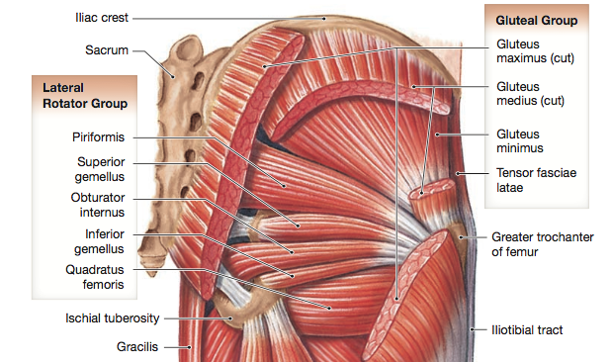
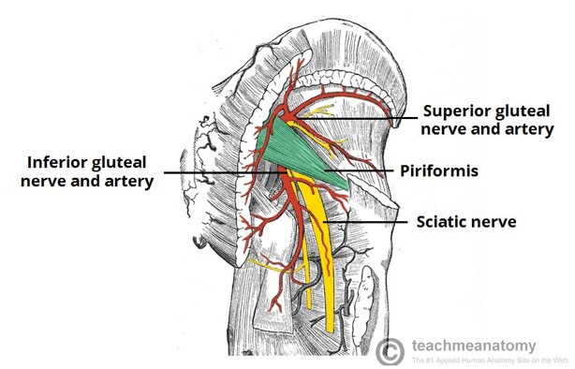

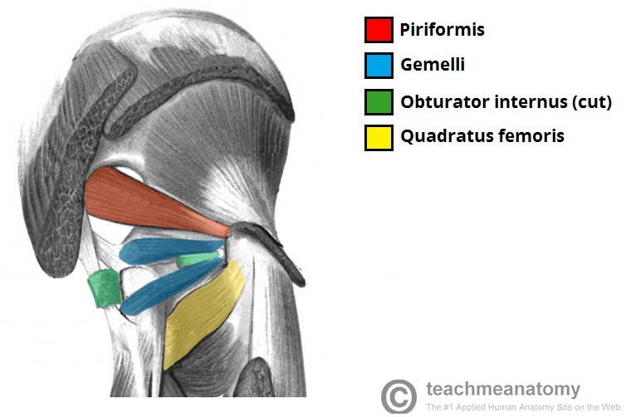
Deep lateral rotators: Just focused on main one….

Piriformis
This is the most superior of the deep muscles.

Origin: anterior surface of the sacrum
Insertion: travels through the greater sciatic foramen to insert into the greater trochanter of the femur

Action: Lateral Rotation and aBduction

Innervation: Nerve to piriformis

Posterior Compartment of the Thigh ‘’Hamstrings’’

Action: Extension at the hip, flexion at the knee
Innervation: Sciatic nerve (L4-S3)

3 originate from ischial tuberosity of the pelvis:
- Long head of biceps femoris
- Semitendinosus
- Semimembranosus

All 4 cross the knee joint

Muscle | Origin | Insertion | Action | Innervation
Biceps Femoris (short head) | Linea aspera of femur | Heads form a tendon and insert into the head of the fibula | Flexion of the leg at the knee | Sciatic nerve
Biceps Femoris (long head) | Ischial tuberosity
Semitendinosus | Ischial tuberosity | Medial condyle of tibia | Flexion of the leg at the knee  Extension of thigh at hip
Semimembranosus | Ischial tuberosity | Medial condyle of tibia | Flexion of the leg at the knee  Extension of thigh at him
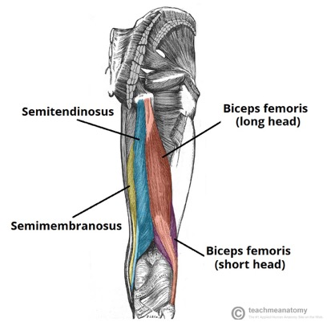
Lateral Aspect:
Biceps femoris (long head and short head)

Medial aspect:
Semitendinosus (tendon is present which makes is distinguishable from semimembranosus)
Semimembranosus (most medial, VERY THICK)
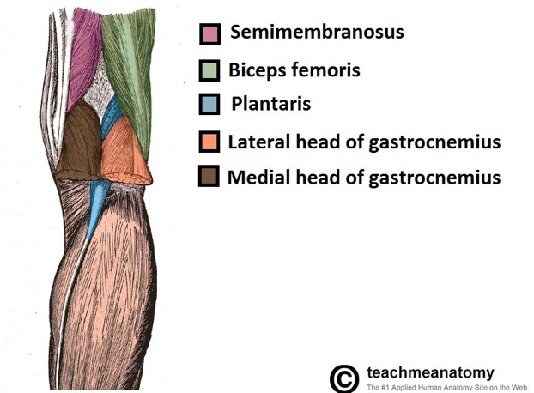
Popliteal Fossa

Sciatic nerve
The nerve emergences from under the piriformis (deep to the gluteus maximus), runs under the long head of biceps femoris and between the lateral and medial posterior thigh muscles to enter the popliteal fossa.

It ends in two terminal division:
- Tibial nerve
- Common peroneal nerve

Borders:
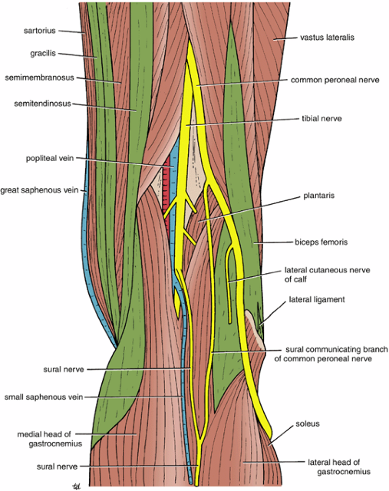
Superiomedial borders: semimebranosus
Superiolareal border: biceps femoris
Inferiomedial border: medial head of gastrocnemius
Inferiolateral border: lateral head of gastrocnemius

Content (medial to lateral)
Popliteal artery
Popliteal vein
Tibial nerve
Common peroneal nerve

*NOTE
Tibial nerve continues south and innervates the posterior aspect of the leg and travels into the plantar surface of the foot

Common peroneal this has a superficial branch and a deep branch
- superficial branch: lateral compartment of the leg
- deep branch: anterior compartment of the leg

*vessels emerge from adductor hiatus and leave between the heads of gastrocnemius

Small saphenous vein
The small saphenous vein pierces the popliteal fascia of the popliteal fossa to enter the ‘diamond’ and empty into the popliteal vein.

SESSION 7: ANTERIOR AND LATERAL COMPARTMENTS OF THE LEG AND DORSUM OF THE FOOT
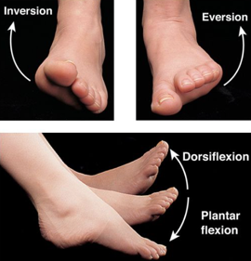
Movements of the foot:
- Dorsi flexion
- Plantar flexion
- Eversion
- Inversion
*Eversion and inversion are based on the direction in which the sole of the foot is pointing

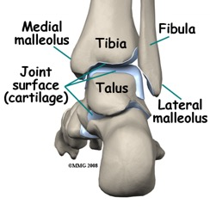
Tibiotalus joint
- tibia and tallus articulation
Dorsi and Plantar Flexion take place here

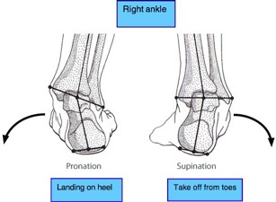
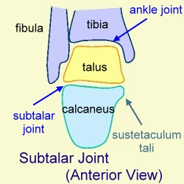
Subtalar joint
This is where the talus articulates with the calcaneum and the navicular
Eversion and Inversion take place here

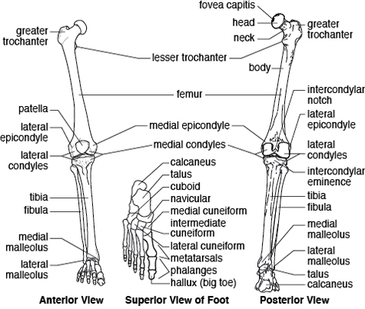
Important points:

The tibia articulates directly with the femur
The fibula articulates directly with the tibia

Just like the ulnar and radial bones, the tibia and fibula have an interosseous membrane

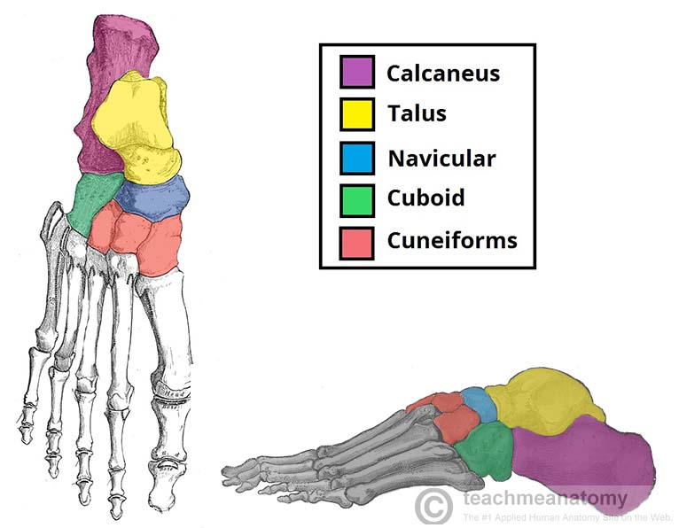
Foot has 7 Tarsels

The Circus Needs More Interesting Little Clowns.

T: Talus
C: Calcaneus
N: Navicular
M: Medial cuneiform
I: Intermediate cuneiform
L: Lateral cuneiform
C: Cuboid

They all contribute to the transverse and longitudinal arches of the foot and are also involved in short absorption.
ANTERIOR COMPARTMENT OF THE LEG

Action:
- Dorsi Flexion and Inversion of the foot at the ankle joint
- Extension of the toes

Innervation: Deep peroneal/fibular nerve

Muscle | Origin | Insertion | Action | Innervation
Tibialis anterior | Lateral surface of the tibia | Medial cuneiform | Dorsiflexion  Inversion | Deep peroneal nerve
Extensor digitorum longus  *there is also an extensor digitorum brevis  (lies lateral and deep to tibialis anterior) | Lateral condyle of the tibia | Fibres converge into tendon, which travel to the dorsal surface of the foot. The tendon the splits into 4. | Extension of 4 lateral toes  Dorsiflexion
Extensor hallucis longus  (located deep to both) | Medial surface of the fibular shaft | Tendon crosses anterior to ankle joint and attaches to distal phalnx of great toe | Extension of great toe  Dorsiflexion
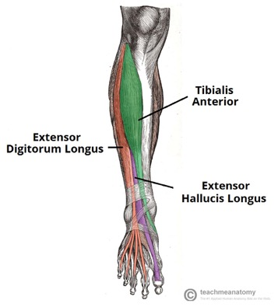

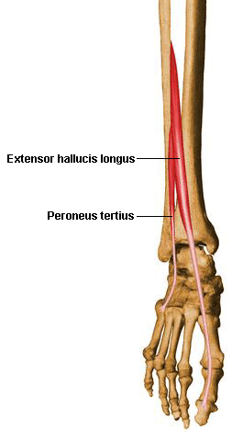
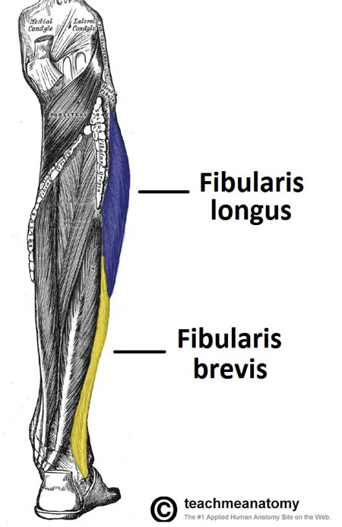
LATERAL COMPARTMENT OF LEG

Action: Eversion
Innervation: Superficial peroneal/tibial nerve
Origin: lateral surface of fibular shaft

- Peroneus/Fibularis longus
- Peroneus/ Fibularis brevis
- Peroneus teritus

Note:
From the anatomical position, you can only do a few degrees of eversion. In reality, the job of these muscles is to fix the medial margin of the foot during running and preventing excessive inversion

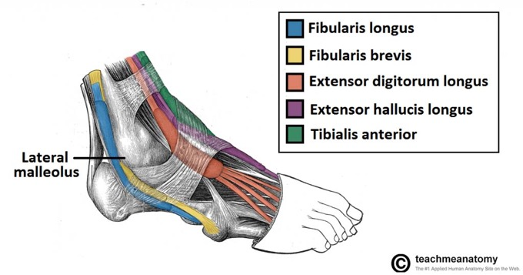
The fibres converge into a tendon, which descends the foot POSTERIOR to the lateral malleolus.

The tendon then crosses under the foot and attaches to the bones on the medial side, namely the media cuneiform i.e. attach to the plantar surface of the foot

POSTERIOR COMPARTMENT OF THE LEG
Action:
Plantar Flexion
Inversion

Innveration:
Tibial nerve (terminal branch of the sciatic nerve)

Muscle | Origin | Insertion | Action | Nerve supply
Superficial |  |  |  | Tibial Nerve
Gastrocnemius  (medial and lateral head)  - Most superficial  - crosses the knee joint | Lateral and Medial femoral condyle | Calcaneal tendon i.e.  Achilles tendon | Plantar flexion  Flexion at the knee
Plantaris | Lateral supracondylar line of the femur |  | Plantar flexion  Flexion at the knee
Soleus  - Deepest of the 3  - Crosses the knee joint | Soleal line of the tibia and proximal fibular area |  | Plantar flexion
Deep
Popliteus  - Forms base of the popliteal fossa | Posterior surface of proximal tibia | Lateral condyle of the femur | Laterally rotates femur on the tibia ‘unlocking’ the knee joint so flexion can occur
Flexor Digitorum Longus | Medial surface of tibia | Plantar surface of lateral four digits | Flexes four toes
Flexor Hallucis Longus | Posterior surface of the fibula | Plantar surface of the phalanx of the great toe | Flexes the great toe
Tibialis Posterior (deepest) | Interosseous membrane | Posterior to medial malleolus and attaches to plantar surface of the foot | *plantar flexion  Inversion
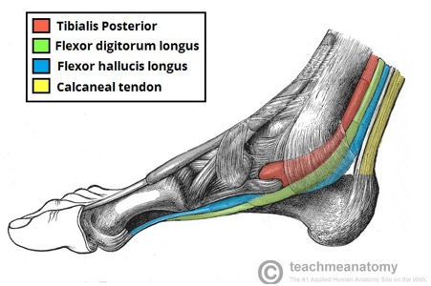
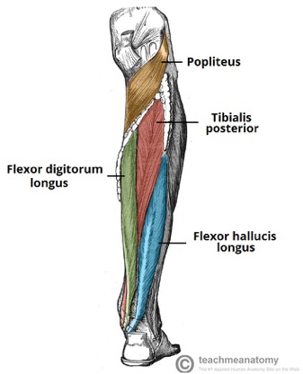
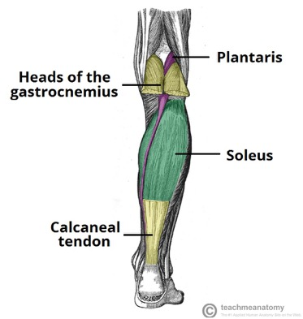

Pictures above:
Superficial and deep layers of the posterior aspect of the leg
Flexor digitorum longus and flexor hallucis longus inserting into the plantar surface of the foot.

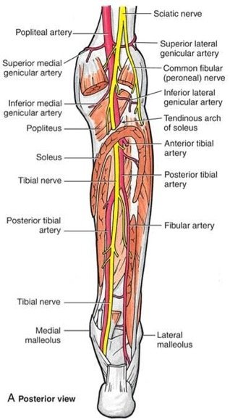
Mnemonic for posterior compartment of the leg
Tall Doctors Are Never Hungry
Structures that pass behind medial malleolus deep to flexor retinaculum
(From anterior to posterior)

- Tibialis posterior
- flexor Digitorum longus
- posterior tibial Artery
- tibial Nerve
- flexor Hallucis longus tendon

MUSCLES ON THE PLANTAR SURFACE OF THE FOOT

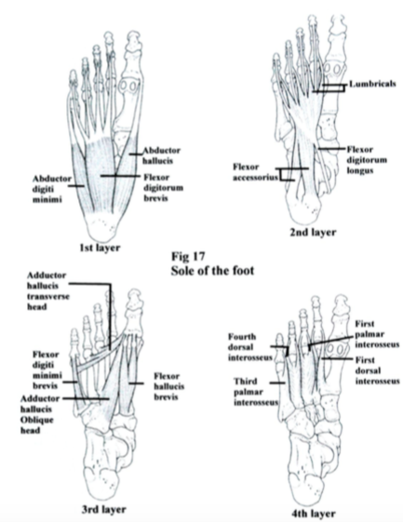

SESSION 8: JOINTS OF THE LOWER LIMB

THE HIP JOINT

- Ball and socket synovial type joint between the head of the femur and the acetabulum of the pelvis
- Joint is a stable weight bearing one
- The head of the femur is hemispherical and fits completely into the concavity of the acetabulum
- Both the head of the femur and acetabulum are covered in articular cartilage

Ligaments:
- Act to increase stability
- Two main categories: Intracapsular and Extracapsular

Intracapsular:
- Ligament of head of femur
Runs from the acetabular fossa to the fovea of the femur
Encloses the obturator artery

Extracapsular
- Ilifemoral
- Pubofemoral
- Ischiofemoral

Vascular Supply: medial and lateral circumflex femoral arteries

Stabalising Factors:
The primary function of the hip joint is to bear weight. There are various structures present that increase its stability.

- Acetabulum
It encompasses nearly all of the head of the femur and this decreases the probability of the head slipping out of the acetabulum and causing a dislocation

- Acetabular Labrum
This is a fibrocartilaginous collar around the acetabulum which increases its depth and it provides a large articular surface therefore improving the stability of the joint.

- Ileofemoral, pubofemoral and ischiofemoral
Strong ligaments and along with the thickened joint capsule. They stabalise the joint greatly.

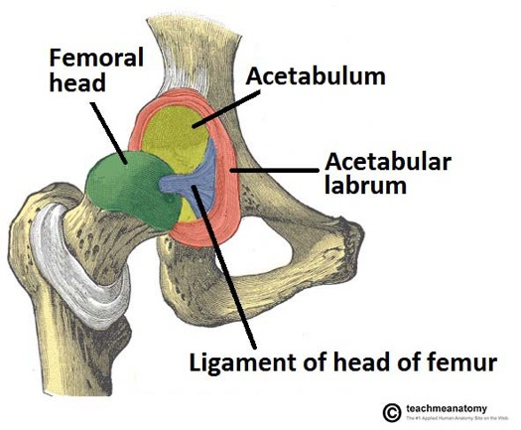
Movements and Muscles

Movements that can be carried out at the hip joint:
- Flexion
- Extension
- Abduction
- Adduction
- Medial/lateral rotation

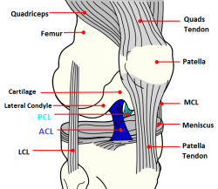
THE KNEE JOINT

Actions: Flexion and extension (small amount of lateral and medial rotation)

- Synovial joint
- Formed by articulations between patella, femur and tibia
- Shape of the knee joint means it is relatively weak and so relies on muscles and ligaments to ensure stability

Articulating surfaces

Two articulations:
Both are lined with hyaline cartilage and enclosed within a single join cavity

- Tibiofemoral
Medial and lateral condyles of the femur articulate with the tibia
- weight bearing joint

- Patellofemoral
Anterior and distal part of the femur articulating with the patella
- allows the tendon of quadratus femoris (main extensor of the kene) to be inserted directly over the knee

Menisci
- Medial and lateral misci which are fibrocartilage structures in the knee that serve to:
- Deepen the articular surface of the tibia therefore increasing stability of the joint
- Act as shock absorbers

Ligaments:

Patellar ligament
Continuation of the quadriceps femoris tendon distal to the patella

Collateral ligaments
Two strap life ligaments which act to stabalise the hinge motion of the knee preventing any medial or lateral movement

- Tibial (medial) collateral ligament
- Fibular (lateral) collateral ligament

Cruciate ligaments
Named by their attachments to the TIBIA

- Anterior cruciate ligament
Prevents anterior dislocation of the tibia onto the femur

- Posterior cruciate ligament
Prevents posterior dislocation of the tibia onto the femur

OTHER JOINTS OF THE LOWER LIMB

Interroseus membrane and inferior tibiofibular joints: connect the tibia and fibula
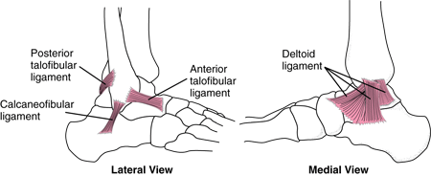

Ankle joint

- deltoid ligament
- anterior and posterior talofibular ligament
- calcaneofibular ligament

All of the above are commonly damaged in a sprain ankle
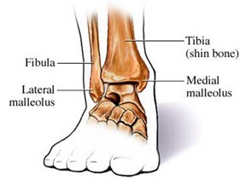

The synovial joint between the lower ends of the tibia and fibula and the talus = ankle joint.
- Plantar Flexion and Dorsiflexion take place at this joint. More specifically, it takes place at the tibiotalus joint

Medial malleoli & Lateral malleoli:
- Both act to stabalise the ankle joint
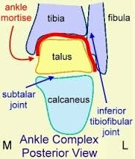

Inferior tibiofibular joint:
A fibrous joint
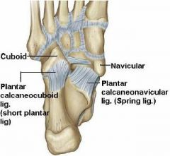
Plantar surface of the foot
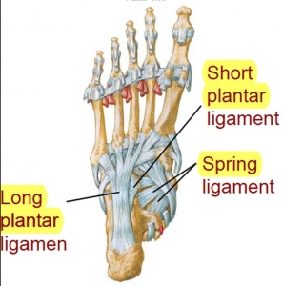
Long plantar Ligament
- Covers the surface of the calcaneum
- Attaches distally to the cuboid bone and the central three tendons

Plantar calcaneonavicular (spring) ligament
- Extends from the sustentaculum tail to the navicular bone.
- The head of the talus rests on its upper surface which forms part of the capsule of the subtalar joint

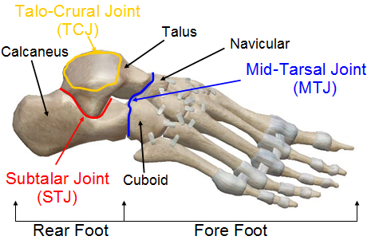
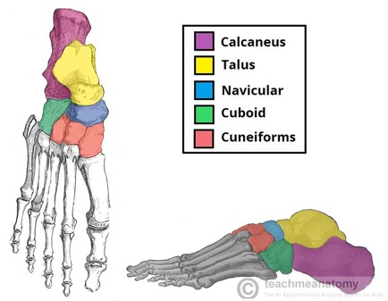
Midtarsal joint
Formed by the articulation between:

Talus and the Navicular (MEDIAL)
(Talonavicular joint)
+
Calcaneus and cuboid bone (LATERAL)
(calcaneocuboid joint)

*Note: the medial component of the midtarsal joint shares the same synovial cavity with the subtalar joint

Inversion and Eversion Movements

Inversion of the foot
- Tibialis anterior and posterior
- Midtarsal joint aDducts

Eversion of the foot
- Peroneus longus and brevis
- Midtarsal joint aBducts

When the foot is on the ground:
- aDudction of the forefoot is masked by lateral rotation of the leg
- Eversion of the a fixed foot is accompanied by medial rotation of the leg

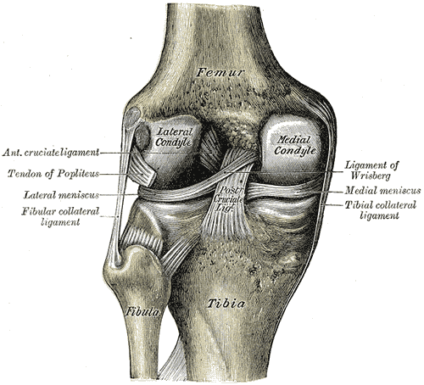
SESSION 8: EXTRA NOTES

Knee Joint
Formed by articulations between the femoral condyles at the tibia.
The fibula DOES NOT articulate with the femoral condyle

Femoral condyles:
- Medial is longer anteriorly and posteriorly
- Lateral has more of a rounded shape

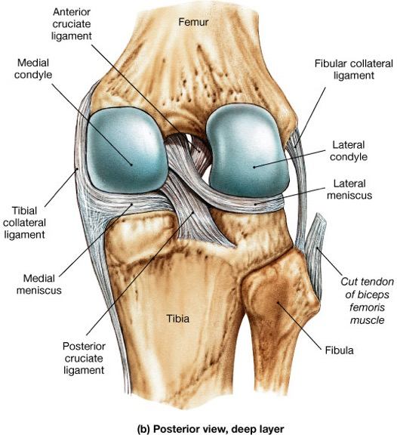
Femur Tibial surfaces
Femur curved surface
Tibia flat surface
- Contains a medial and lateral tibial plateau on which the lateral and medial meniscus lie

Menicus
- Lateral meniscus moves!!
- Medial meniscus does not move and therefore is more commonly damaged

Primary and secondary articulations

1º articulation
Lateral femoral condyles with the lateral tibial plateau

2º articulation
Medial femoral condyles with the medial tibial plateau

Collateral ligaments

Medial (tibia) collateral ligaments – it is part of capsule
Lateral (fibula) collateral ligaments – it is not part of the capsule

Cruciate Ligaments
Anterior cruciate ligament – from the front of the tibia to the back of the femur
*damaged more commonly!

Posterior cruciate ligament – from the back of the tibia to the font of the femur

