Endocrine and reproduction peer teaching notes

PREGNANCY AND MENSTRUAL CYCLE

- Hormonal changes - the different hormones produced during pregnancy and their actions
  - ADD GRAPH OF HORMONE CHANGES
  - Oestrogen - produced throughout pregnancy, regulates levels of progesterone, prepares the uterus for baby (stimulates growth of uterine mass), prepares the breasts for lactation, induces synthesis of receptors for oxytocin, first 2 months = supplied by corpus luteum, then by placenta.
  - Progesterone - prevents miscarriage builds up endometrium for support of placenta, inhibits uterine contractility – so fetus is not expelled prematurely. Increases throughout pregnancy. First 2 months = supplied by the corpus luteum.
  - hCG - stimulates Oestrogen / progesterone production by ovary, pregnancy test hormone – diminishes once the placenta is mature enough to take over oestrogen / progesterone production.
  - Prolactin - produced by the anterior pituitary gland, increases cells that produce milk, prevent ovulation (unreliably), after birth, oestrogen and progesterone levels decrease, allowing prolactin to stimulate milk production (also controlled by suckling)
  - Relaxin - high in early pregnancy, produced by ovary and placenta, helps limit uterine activity, softens cervix & involved in cervical ripening for delivery.
  - Oxytocin - triggers ‘caring’ reproductive behaviour, responsible for uterine contractions during pregnancy and labour (drug used to induce labour).
  - Prostaglandins - PGF2a = main one (PGE2 10x more powerful). Tissue hormones – role in initiation of labour; synthetic prostaglandins used to induce labour.
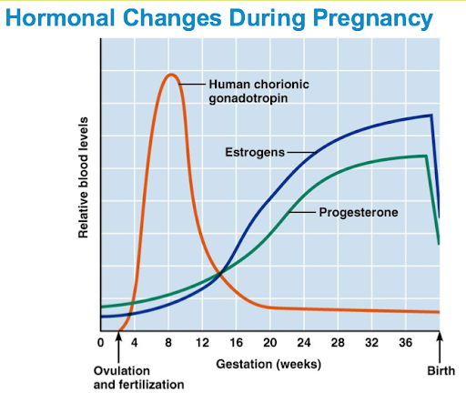
- Maternal adaptations - cardiovascular, veins, skin
  - CVS:
    - Increased CO
    - Decreased systemic BP
    - Decreased total peripheral resistance
    - Increased uterine blood flow
    - Increased blood volume
    - Increased plasma and blood cell mass
    - Varicose veins
  - Resp
    - Increased alveolar ventilation
  - GI
    - Increased acid reflux
    - Gastroparesis (delayed emptying)
  - Skin changes:
    - Linea nigra
    - Striae gravidarum
    - Darkened areola
  - Biochemical changes
    - Weight gain – maternal and fetoplacental. Obese women don’t put much weight on as have fat stores
    - Increased protein and lipid synthesis
    - Insulin resistance
- Initiation of labour - hormonal involvement Layers of the uterus and cervical ripening
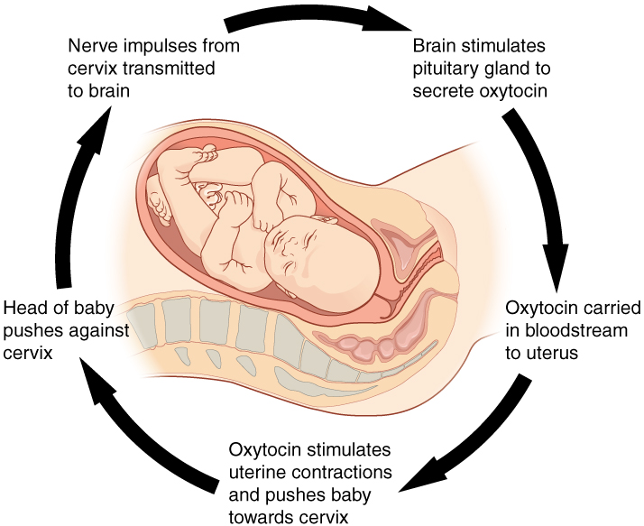
  - Labour (aka parturition) has 3 stages – occurs 40 weeks after the 1st day of the last menstrual cycle
  - Need cervical ripening (softening of cervix) for labour to commence – allows dilation
    - Occurs in response to oestrogen, relaxin and prostaglandins breaking down cervical connective tissue
  - Relative decrease in progesterone in relation to oestrogen increases the excitability of the uterine musculature as well as mechanical stretching of the uterus as the fetus grows. This increases contractility
  - Oxytocin – initiates uterine contractions. After 36 weeks there is an increase in oxytocin receptors so the uterus begins to respond to the pulsatile release of oxytocin from the posterior pituitary gland. Contractions cause positive feedback releasing more oxytoin and stronger contactions – Ferguson reflex
  - Stages of labour:
    - First stage – from beginning of labour until the cervix is fully dilated (10cm):
      - Latent phase – slow cervical dilation over several hours until cervix is 4cm
      - Active phase – faster dilation, until 10cm.
    - Second stage – from full dilation until baby is delivered
    - Third stage – after delivery, until the placenta has been delivered
  - Layers of the uterus:
    - Perimetrium – outermost serous layer (visceral peritoneum)
    - Myometrium – middle layer, interlacing layers of smooth muscle
    - Endometrium – mucosal lining of uterine cavity, changes thickness during menstrual cycle
- The placenta - hormones, function, structure and development
  - Takes over from endometrial cells (provide first few weeks of nutrition).
  - Provides nutrition, gas exchange, water removal, endocrine and immune support
  - Development - blastocyst implants on the endometrium, the outermost layer, called the syncytiotrophoblast, grows into the endometrium. It forms finger-like projections called chorionic villi. The chorionic villi contain fetal blood vessels. The chorionic villi nearest the connecting stalk of the developing embryo are the most vascular and contain mesoderm. This area is called the chorion frondosum. The cells in the chorion frondosum proliferate and become the placenta. The connecting stalk becomes the umbilical cord. Placental development is usually complete by 10 weeks gestation.
  - Hormones:
    - hCG – supports corpus luteum
    - hcS (somatotropin) – stimulates mammary development
    - progesterone and oestrogen – supports maternal endometrium
    - relaxin
- Follicular development (granulosa cells surround oocyte, forming the follicle)
  - Primordial follicle → small primary follicle → secondary (preantral) follicle → pre-ovulatory (antral) then ovulation → luteinization → corpus luteum → luteolysis/regression of follicle
  - Primary follicles developing into secondary is always happening
- The menstrual cycle - follicular phase, ovulation and luteal phase
  - Has two phases:
    - Follicular phase (start of menstruation to ovulation – 14 days)
      - When follicles reach the secondary follicle stage, they develop receptors for FSH. To develop after the secondary follicle stage, they require stimulation from FSH
      - As the follicles grow, the granulosa cells secrete increasing amount of oestrogen which has a negative feedback on the pituitary gland, decreasing LH and FSH. Increasing oestrogen also makes the cervical mucus more permeable, allowing sperm to penetrate the cervix around the time of ovulation
      - One follicle develops further than the others, becoming the dominant follicle
      - LH spikes just before ovulation, causing the dominant follicle to release an ovum from the ovary
      - Ovulation happens 14 days before the end of the cycle
    - Luteal phase (from ovulation to the start of menstruation – 14 days)
      - Follicle which release the ovum then collapses and becomes the corpus luteum
      - The corpus luteum secretes high levels of progesterone to maintain the endometrial lining and thicken the cervical mucus
      - Corpus luteum also secretes a small amount of oestrogen
      - At fertilisation, the syncytiotrophoblast of the embryo secrete HCG which maintains the corpus luteum
      - If no fertilisation, the corpus luteum degenerates causing a fall in oestrogen and progesterone
      - This causes the endometrium to break down and menstruation occurs
      - The stromal cells of endometrium release prostaglandins which encourage the breakdown of the endometrium
      - Menstruation starts on day 1 of the menstrual cycle
      - Negative feedback from oestrogen and progesterone on the hypothalamus and pituitary gland ceases, allowing LH and FSH levels to rise so the cycle restarts
- Hormonal levels during the menstrual cycle (and identification from graph)
  - See above
  - 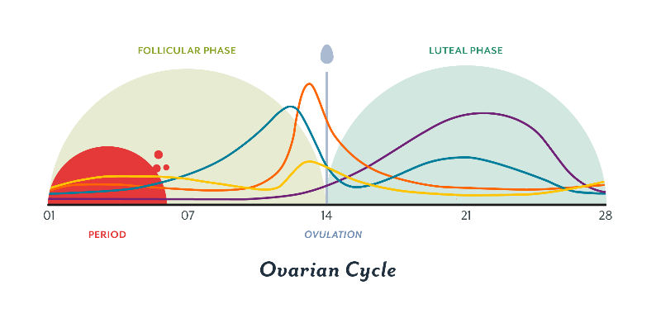
- Fertilisation and implantation
  - Fertilisation:
    - Around ovulation the primary oocyte undergoes meiosis leaving a haploid cell. The other 23 chromosomes become a polar body
    - Fertilisation occurs at ampulla of fallopian tube
    - Sperm attempt to penetrate the corona radiata and zona pellucida to fertilise the egg, usually only one sperm will get through before the layers shut the other sperm out
    - When a sperm enters, the 23 chromosomes of the egg multiply into 2 sets. One set combines with the 23 chromosomes from the sperm and the other 23 create the second polar body
  - Implantation
    - The fertilised cell is called a zygote
    - The zygote divides rapidly to form the morula. During this process the mass of cells travels along the fallopian tube towards the uterus
    - While travelling, it becomes a blastocyst and loses the outer two layers. When the blastocyst enters the uterus (8-10 days after ovulation), it contains 100-150 cells
    - The cells of the trophoblast adhere to the stroma of the endometrium
    - The syncytiotrophoblast forms projections into the stoma
    - When implantation occurs, the syncytiotrophoblast starts to produce HCG
    - HCG helps maintain the corpus luteum in the ovary so it continues to produce progesterone and oestrogen

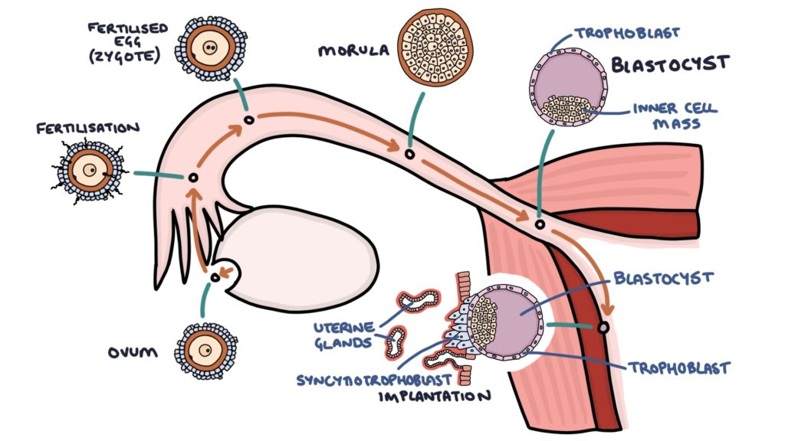

EMBRYOLOGY

Mesonephric = Wolffian ducts
Paramesonephric = Mullerian

- Genital development - the indifferent stage
  - Cant distinguish between male and female
  - Begin as genital ridges (pair of longitudinal ridges from the intermediate mesoderm and overling epithelium). Initially don’t contain any germ cells.
- Primordial germ cell migration
  - In 4th week, germ cells migrate from endoderm lining of yolk sac to genital ridge via dorsal mesentery of hindgut. Reach genital ridge in week 6
  - At same time, epithelium of genital ridge proliferates and penetrates intermediate mesoderm to form primitive sex cord
  - Indifferent gonad forms – develops into ovaries or testes
- Development of the testes
  - Male embryo contains XY chromosomes
  - Y chromosome contains SRY gene which stimulates the development of the primitive sex cords to form testis cords
  - Tunica albuginea (fibrous connective tissue layer) forms around the cords
  - A portion of the testis cords breaks off to form the future rete testis
  - Remaining cords contain two types of cell:
    - Germ cells
    - Sertoli cells (derived from surface epithelium of the gland)
  - Between the testis cords are the leydig cells (derived from intermediate mesoderm). In 8th week, they begin to produce testosterone which drives differentiation of the external genitalia
- Development of external genitalia
  - Begins in 3rd week
  - Mesenchymal cells from primitive streak migrate to the cloacal membrane forming a pair of cloacal folds
  - Cranially the folds fuse to form the genital tubercle
  - Caudally they divide into the urethral folds (anterior) and the anal folds (posterior)
  - Genital swellings develop either side of the urethral folds
  - Male:
    - Driven by androgens from the testes (dihydrotestosterone, DHT)
    - Rapud elongation of genital tubercle becoming the phallus
    - Urethral folds pulled to form urethral groove which extends along the caudal aspect of the phallus.
      - Folds close by 4th month forming the penile urethra
    - Genital swellings become the scrotal swellings, moving causally tp eventually form the scrotum
  - Female:
    - Oestrogens responsible for external genitalia development
    - Genital tubercle elongates slightly to form the clitoris
    - Urethral folds and genital swelligns don’t fuse – form labia minora and majora respectively
    - Urogenital groove remains open – forms vestibule where urethra and vagina open
- Uterine development from the Mullerian duct and formation of the vagina
  - No leydig cells in females to produce testosterone so mesonephric ducts degenerate leaving behind Gartner’s duct
  - Absence of anti-Mullarian hormone allows for development of paramesonephric (Mullarian) ducts which initially have three parts:
    - Cranial – becomes fallopian tube
    - Horizontal – becomes fallopian tube
    - Caudal – fuses to form uterus, cervix and upper 1/3 of vagina
  - Lower 2/3 of vagina formed by sinovaginal bulbs (derived from pelvic part of urogenital sinus)
- Development of the bladder and urethra
  - Urinary system develops ahead of the reproductive system
  - Bladder and urethra ultimately derived from the cloaca (hindgut structure)
  - In the 4th-7th week of development the cloaca is divided into two parts by the uro-rectal septum:
    - Urogenital sinus (anterior) divided into 3 parts:
      - Upper part forms bladder
      - Pelvic part forms urethra and sme of the reproductive tract in females, the prostatic and membranous urethra in males
      - Phallic/caudal part forms part of the female reproductive tract amd the spongy urethra in males
    - Anal canal (posterior)
  - Urinary bladder initially drained by the allantois – obliterated and becomes a fibrous cord (urachus) during fetal development
  - As bladder develops form the urogenital sinus it absorbs the caudal part of the mesonephric ducts becoming the trigone of the bladder
  - The ureters (form as outgrowths of the mesonephric ducts) enter the bladder at the base of the trigone
  - Final structure varies between sexes:
    - Males:
      - As kidneys ascend into abdo, ureteric openings move cranially and mesonephric ducts move caudally and closer together entering the prostatic urethra to become the ejaculatory ducts
      - Pre-prostatic, prostatic and membranous urethra is formed from the pelvic part of the urogenital sinus. Spongy urethra is formed from the phallic part of the urogenital sinus
    - Female:
      - As kidneys ascend, ureteric openings move cranially . Mesonephric ducts degenerate due to lack of testosterone
      - Urethra formed from pelvic part of the urogenital sinus

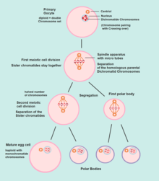
REPRODUCTION

Spermatogenesis and oogenesis

- Meiosis (I and II)
- Oogenesis
  - Oogonia
  - Mitotic division starts before 12 weeks
  - Producing primary oocytes which begin meiosis
  - Meiotic arrest – metaphase 1 until puberty
  - Primary oocytes go through remainder of meiosis I to make secondary and polar body
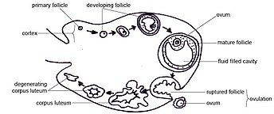
  - Secondary oocytes go through meiosis 2 producing 1 ovum and 1 polar body
    - Large ovum as it takes everything needed for production of foetus mitochondria
  - Group of oogonia in ovaries
  - Some die and become theca cells and granulosa cells
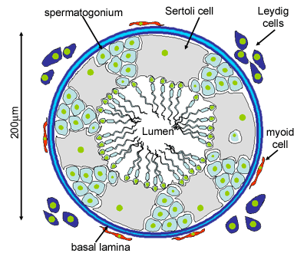
  - Granulosa cells form follicle around ovum
  - Theca cells inside the follicle and provide nutrition to maturing ovum
  - Once ovum is mature follicle opens and ovulation happens
  - Follicle the degrades forming corpus luteum
  - Corpus luteum responsible for making oestrogen and inhibiting GnRH and therefore LH and FSH
  - Eventually degrades

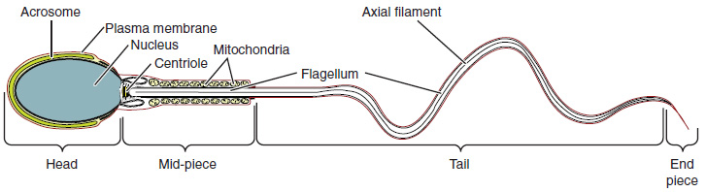
- Spermatogenesis
  - 200 million a day
  - Occurs in the seminiferous tubules in testes
  - To keep this separate from the systemic circulation a blood testes barrier is formed
  - Blood testis barrier is formed by Sertoli cells and the tight junction between them
  - Substances in blood don’t affect sperm protection from immune system – genetically different so would get attacked
  - Spermatogonia are the initial pool of the diploid cells
    - Type A – replenish pool of spermatogonia
    - Type B – form mature sperm
  - Type B spermatagonia repliocate by mitosis to form identical diploid cells linked by cytoplasm bridges these are primary spermatocytes
  - Primary spermatocytes undergo meiosis
  - Meiosis I produces secondary spermatocytes
  - Meiosis II produces spermatids
  - Bridges break and spermatids released into lumen of seminiferous tubule – spermiation
  - Spermatids undergo spermeogenesis
  - Cells travel to rete testis – concentrates the sperm (removes excess water)
  - Move to epididymis where they are stored and have final maturation

Changes at puberty

- controlled by the hormones of the Hypothalamic-Pituitary-Gonadal (HPG) axis.
  - Hypothalamus releases Gonadotropin Releasing Hormone (GnRH) (pulsatile manner
  - stimulates the release of Follicle Stimulating Hormone (FSH) and Luteinizing Hormone (LH) from the anterior pituitary gland.
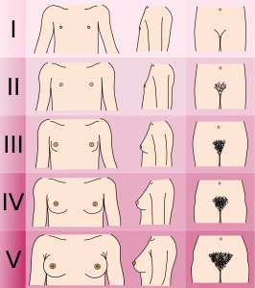
  - Male – LH + Leydig cells (testosterone) FSH and Sertoli cells (spermatogenesis)
  - Female – LH theca cells (progesterone) FSH and granulosa cells (oestrogen synthesis and oogenesis)
- Increased GnRH release causes puberty
- Female
  - 9-10 Brest formation
  - 1.5-3 years later first period (12.8 years on Caucasian girls)
  - Meiotic arrest stops
  - Measured on tanner staging system
  - Restarting of oogenesis
- Males
  - 11.6 years Increase in testicular size
  - Increase in LH increases testosterone FSH stimulates spermatogenesis – increased spermatogenic tissue causes increased size of testes
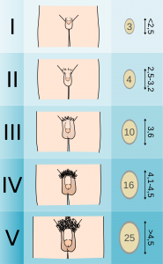
  - Approx. year later can ejaculate and theoretically procreate (average fertility reached year after first ejaculation)
  - Tanner staging
- Pubic hair (secondary sexual characteristic mediated by testosterone both male and female)
  - Initially in pubic region
  - 2 years after start on arms legs armpits chest and face
- Growth spurt
  - 8.3cm/year female 9.5cm/year male
  - Males produce Adam’s apple – larynx and vocal cords enlarge
- Precocious puberty – early onset – increased levels of hormones
- Delayed or absent – Turner’s, Klinefelter, insensitive to androgens
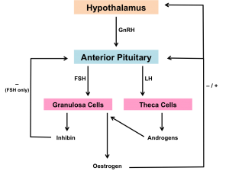

Physiological changes at menopause

- Commences at 45 finishes at 51 (UK advert)
- Defined as Amenorrhoea for 12 months
- Hormonal changes
  - Characterised by the reduction of circulating oestrogen
  - Results from reduced sensitivity of the ovaries to FSH and LH
    - Reduced Binding sites due to decreased number of follicles
  - FSH and LH levels rise as less oestrogen to inhibit them
- Common symptoms
  - Hot flushes
    - Red flush starting with face spreading down neck and chest
    - Peripheral vasodilation – Don’t really know why – LH influencing temp control
  - Urogenital changes
    - Atrophy of vagina and thinning of myometrium
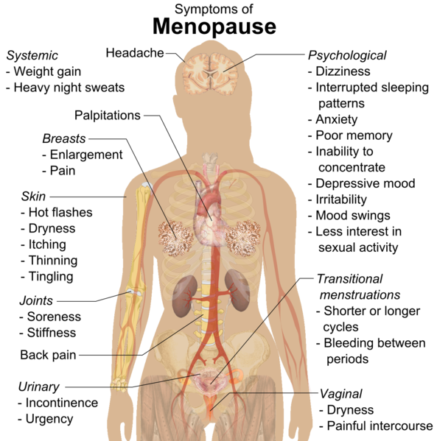
    - Thinning of walls and dryness
    - Can result dyspareunia (pain during sex)
    - UTIs
    - Urinary incontinence
      - Atrophy if bladder and urethra – share same embryology
  - Irregular vaginal bleeding
  - Bone density
    - Oestrogen protects bone mass and density (reduces activity of osteoclasts)
  - Ischaemic hear disease
    - Oestrogen is protective factor
    - Reduces LDL and raises HDL
    - Have same level of CVD as men postmenopausal
  - Increased risk of dementia

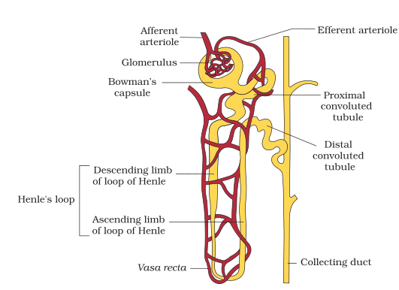
HISTOLOGY
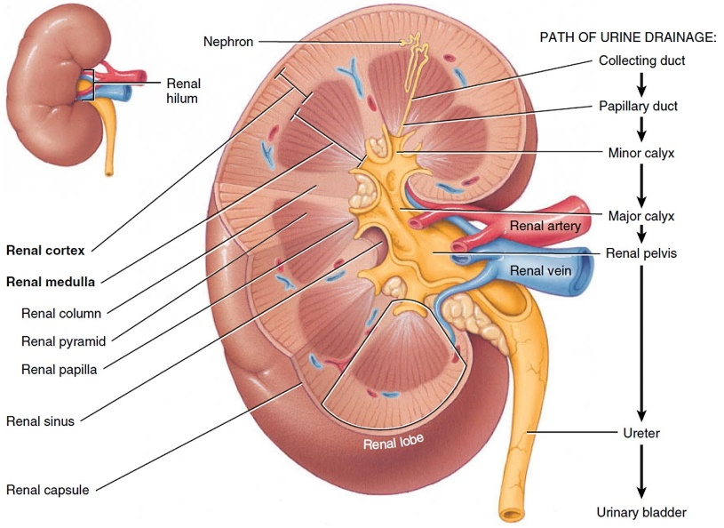
Histology of the nephron

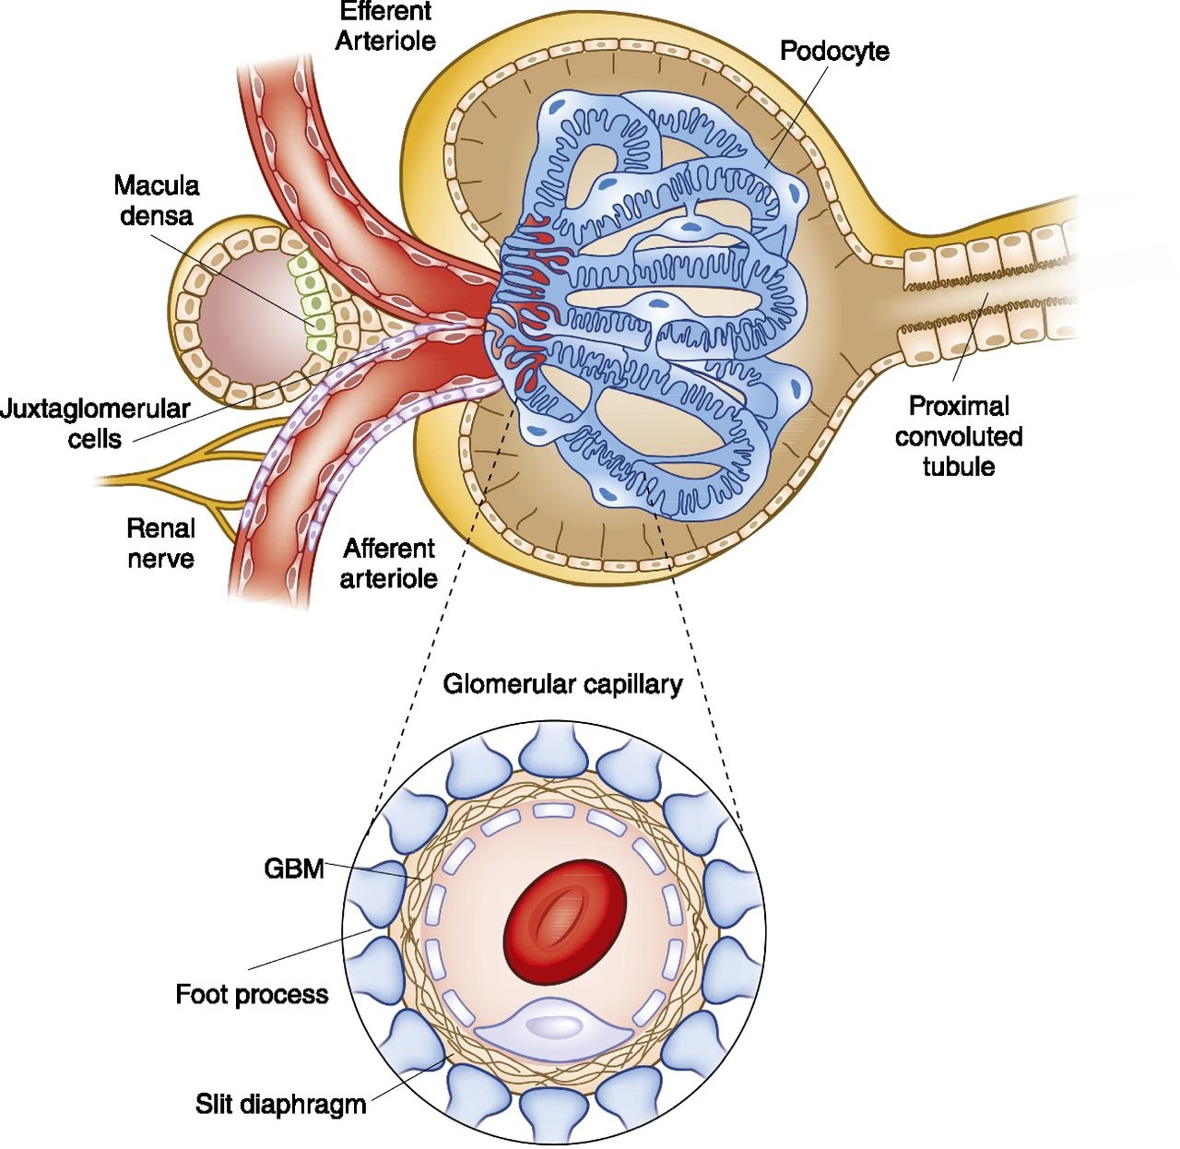
Histology of the spermatic cord - seminiferous tubule, epididymis, vas etc.

- Spermatic Cord – 33333
  - 3 Arteries
    - Testicular
    - Artery to vas
    - Cremasteric
  - 3 Veins
    - Testicular (pampiniform plexus)
    - Vein of Vas
    - Cremasteric
  - 3 Nerves
    - Cremasteric
    - Genital branch of genitofemoral nerve
    - Sympathetics
  - 3 Fascial coverings
    - Internal spermatic fascia (transversus)
    - Cremasteric muscle and fascia (internal oblique)
    - External spermatic fascia (external oblique)
  - 3 Others
    - Vas deferens
    - Processus vaginalis
    - Lymphatic
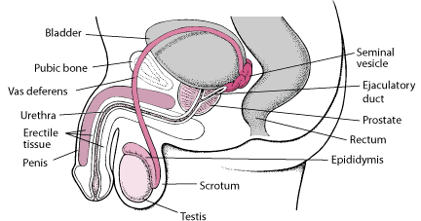

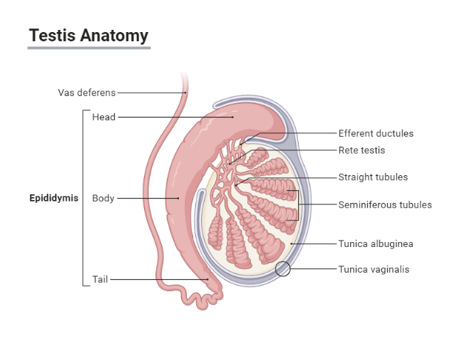
Path of sperm

- Seminiferous tubules
- Rete testes
- Efferent ducts
- Epididymis
- Vas deferens
- Ejaculatory duct
- Urethra
- Penile urethra
Histology of the urethra and prostate

- Urethra
  - Prostatic
  - Membranous
  - Penile
- Urothelium
  - pseudostratified columnar, with overlying umbrella cells
  - Renal pelvis to proximal penile urethra
    - Renal pelvis
    - Ureter
    - Bladder
    - Prostatic urethra
    - Membranous urethra
    - Proximal penile urethra
  - Distally stratified squamous

Histology of vaginal epithelial squares

- Stratified squamous
  - Keratinised towards vulval end

Proliferative and secretory endometrium

- Proliferative
  - Post-menses 10 days
  - Regrowing gland and blood vessels
  - Tubular glands are straight
  - Mitotic figures present
- Secretory
  - Ovulation day (14-16)
  - Cells have large vacuole
  - Spiral arteries
  - Oedematous stroma
Corpus luteum

- Follicle ruptures
- Theca cells persist forming corpus luteum
- Secretes oestrogen and progesterone for 10 days
- 4 weeks if fertilisation occurs
- Becomes corpus albicans

Anterior and posterior pituitary gland, pineal gland, parathyroid, thyroid (follicular cells and c cells), pancreatic islets and suprarenal cortex and medulla

- Anterior pituitary
  - Alpha
  - Beta
  - Chromophobes
- Posterior
  - Granules containing
    - Oxytocin
    - Vasopressin
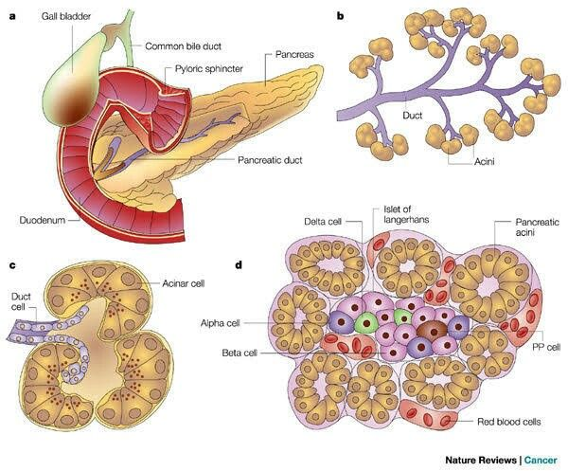
- Pineal gland
  - Secretes melatonin
- Thyroid
  - Folllicular cells
  - C cells
    - Produce calcitonin (promotes uptake of calcium into bones)
- Pancreas
  - Alpha – glucagon
  - Beta – insulin
  - Delta – somatostatin
  - Polypeptide-secreting cells
- Adrenal Glands
  - Cortex
    - Zona Glomerulosa
      - Salt – Mineralcorticoids - aldosterone
    - Zona fasculata
      - Sugar – glucocorticoids - cortisol
    - Zona Reticularis
      - Sex – androgens – DHEA (dehydroepiandrosterone)
  - Medulla
    - Adrenaline
    - Noreadrenaline
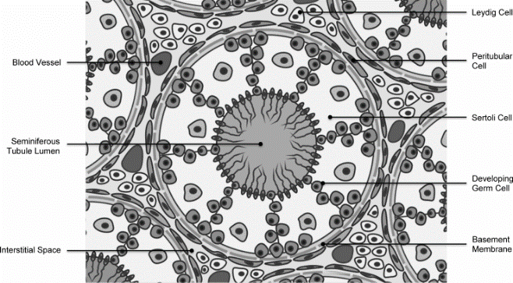
Leydig cells

- Surround seminiferous tubules

Hairy skin, epithelial layers

- Stratified squamous keratinized epithelium
- Layers of epidermis
  - Stratum corneum
  - Stratum lucidum (only in thick skin; palms and soles)
  - Stratum granulosum
  - Stratum spinosum
  - Stratum basale

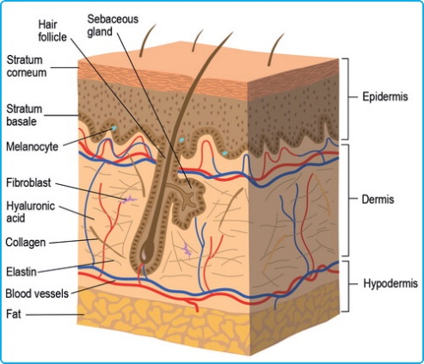
Breast tissue (lactating and none-lactating), lactiferous duct

- Lactating
  - Mammary alveoli displace fat tiddue
- Lactiferous duct
  - Many branches converge to connect to nipple
- Non-lactating
  - Adipose tissue

