**Contraindications to combined hormonal contraceptives:**

Migraine with aura Hypertension Stroke

[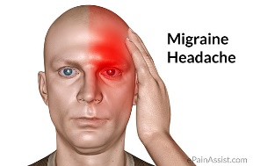](http://www.google.co.uk/url?sa=i&rct=j&q=&esrc=s&source=images&cd=&cad=rja&uact=8&ved=0CAcQjRxqFQoTCJypsvDo0scCFeuc2wodomYAgw&url=http://www.epainassist.com/headache/migraine-headache-or-neurovascular-headache&ei=DAXkVZzzKOu57gaizYGYCA&psig=AFQjCNEtAgYGycR2Gi5MxJXc-VtAeehecA&ust=1441093249820802) [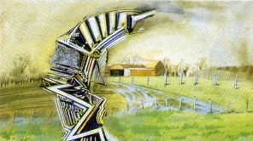](http://www.google.co.uk/url?sa=i&rct=j&q=&esrc=s&source=images&cd=&cad=rja&uact=8&ved=0CAcQjRxqFQoTCIvguZHp0scCFadu2wodiOgA4Q&url=http://www.worldsciencefestival.com/2012/11/what_is_migraine_aura/&ei=UQXkVcvzPKfd7QaI0YOIDg&psig=AFQjCNF8PR5pPXIwRB7DKhX1K02LiJXmFg&ust=1441093304903822) [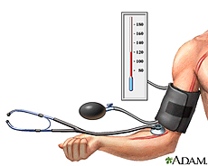](https://www.google.co.uk/url?sa=i&rct=j&q=&esrc=s&source=images&cd=&cad=rja&uact=8&ved=0CAcQjRxqFQoTCKmopaTp0scCFSKB2wod6VMGAg&url=https://www.nlm.nih.gov/medlineplus/highbloodpressure.html&ei=eQXkVemHH6KC7gbpp5kQ&psig=AFQjCNG4XkvJktSG9fRYm4ITETN_ybsSRQ&ust=1441093364632717) [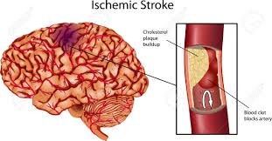](http://www.google.co.uk/url?sa=i&rct=j&q=&esrc=s&source=images&cd=&cad=rja&uact=8&ved=0CAcQjRxqFQoTCOSN3snp0scCFcsG2wodRfoLPA&url=http://www.123rf.com/photo_13699566_brain-stroke--a-illustration-of-ischemic-stroke.html&ei=yAXkVeSJAsuN7AbF9K_gAw&psig=AFQjCNFkOObEQ3Pev2wUnjkkKASTCXYKuA&ust=1441093406033197)

Ischaemic heart disease Venous thromboembolism

[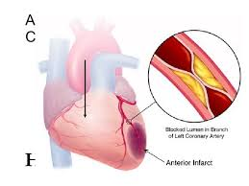](http://www.google.co.uk/url?sa=i&rct=j&q=&esrc=s&source=images&cd=&cad=rja&uact=8&ved=0CAcQjRxqFQoTCOzwr-np0scCFcRr2wod4SkBTA&url=http://www.slideshare.net/dplnanded/ischemic-heart-diseases-presentation&ei=CgbkVezDF8TX7Qbh04TgBA&psig=AFQjCNHDbLkLFxECdfbe2gyEcI4vMvk60Q&ust=1441093497758024) [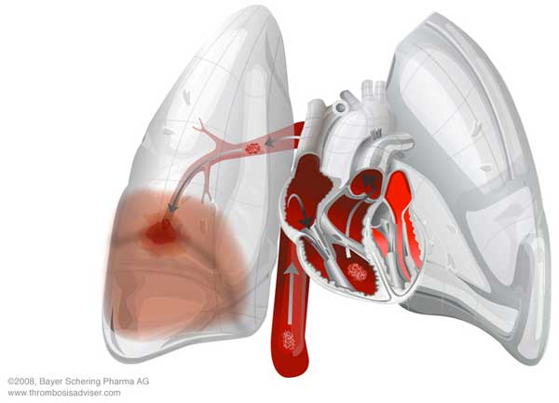](http://www.google.co.uk/url?sa=i&rct=j&q=&esrc=s&source=images&cd=&cad=rja&uact=8&ved=0CAcQjRxqFQoTCIOOp5vq0scCFaRp2wodFQMMkA&url=http://www.copybook.com/pharmaceutical/venous-thromboembolism-risk&ei=cwbkVcOIBqTT7QaVhrCACQ&psig=AFQjCNH--obv1PwgklPzAh3DCTZM3MiZ6w&ust=1441093616201574) [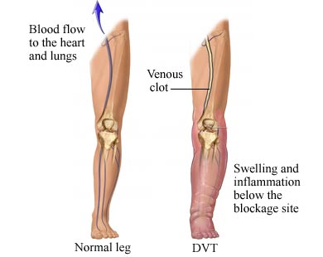](http://www.google.co.uk/url?sa=i&rct=j&q=&esrc=s&source=images&cd=&cad=rja&uact=8&ved=0CAcQjRxqFQoTCIrfyrHq0scCFckX2wodtysPlw&url=http://www.circulationfoundation.org.uk/help-advice/veins/venous-thrombosis-dvt-air-travel/&ei=oQbkVcqKMsmv7Aa317y4CQ&psig=AFQjCNGrz5D0OHTOjOHFbDsMqXjyj8Lskw&ust=1441093583707816)

Breast cancer BMI> 35 Smoker over 35

[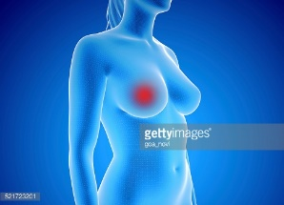](http://www.google.co.uk/url?sa=i&rct=j&q=&esrc=s&source=images&cd=&cad=rja&uact=8&ved=0CAcQjRxqFQoTCPyM99Xq0scCFYoF2wodfRAKdQ&url=http://www.gettyimages.com/detail/illustration/3d-rendered-illustration-of-breast-cancer-royalty-free-illustration/521723201&ei=7gbkVfzdAoqL7Ab9oKioBw&psig=AFQjCNGuxvsFKNy62uRvJgnNFiw-Br6smw&ust=1441093725495616) [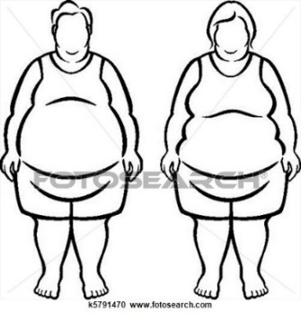](http://www.google.co.uk/url?sa=i&rct=j&q=&esrc=s&source=images&cd=&cad=rja&uact=8&ved=0CAcQjRxqFQoTCM7SoO_q0scCFSdZ2wodFggFHw&url=http://www.fotosearch.com/CSP578/k5780089/&ei=IwfkVY61Caey7QaWkJT4AQ&psig=AFQjCNGM9nX5UFlsyrqAkZ0LH_4oICWQiA&ust=1441093792084991) [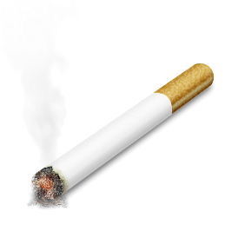](http://www.google.co.uk/url?sa=i&rct=j&q=&esrc=s&source=images&cd=&cad=rja&uact=8&ved=0CAcQjRxqFQoTCLSz4ITr0scCFSWa2wodEgcAeA&url=http://nobacks.com/photos/objects/cigarettes/page/3/&ei=UAfkVbTLDqW07gaSjoDABw&psig=AFQjCNE7Yie7RPzCRkgp-IabJ_ooD_pffg&ust=1441093836809094)