DOCSS Assessment Document
Phase 2a Sheffield Medical School
By Melanie Coulson

BEFORE ANY PROCEDURE- CHECK NAME, DOB, AND HOSPITAL NUMBER USING WRISTBAND AND PATIENT NOTES. THEN ALWAYS HAND GEL.

GET CONSENT AT THE START OF EVERY PROCEDURE;
W -wash hands
I -introduce yourself and identify patient
P -permission
E -expose patient appropriately
R -reposition patient as you need

Top tips;
- Watch the videos and look at the mark schemes on Minerva!
- Practice the ‘spiel’ with your friends and answering the pre-made questions
- Practice writing a list of what you need to gather for each procedure
- Go to SFH when there are practice sessions to brush up on your skills
- Be aware of timings as they are strict on this on the day
- Wear appropriate clinical dress and be bare below the elbows on the day

ECG and cardiac monitor
(They will already have their electrodes placed but these will be covered and you need to indicate where you would put them). You should then attach the appropriate wires and obtain 12L ECG and monitor trace for patient.
For 12-lead ECG:
Limb leads (over bone where possible):
- right arm (red lead),
- left arm (yellow lead),
- left leg (green lead),
- right leg (black lead)
Chest leads:
- C1 = 4th intercostal space, right sternal border;
- C2 = 4th intercostal space, left sternal border;
- C3 = half-way between C2 and
- C4; C4 = 5th intercostal space, mid-clavicular line;
- C5 = anterior axillary line at the same horizontal level as C4;
- C6 = mid-axillary line at the same horizontal level as C4 and C5.
ECG;
- Gather equipment
- Identify patient
- Explain the procedure- ‘I’ve been asked to take some recordings of your heart, this will involve me placing some stickers on your chest, arms and legs. I’ll then attach the stickers to some leads which are part of the machine. These will then take a recording of your heart. You shouldn’t feel any pain. The procedure will involve you being exposed down to your waste is that ok? I will also need to have access to your ankles. Would you like a chaperone?’
- Gain consent and check allergies (to stickers)
- Washes hands with alcohol gel
- Indicate electrode sites on diagram
- Attach lead wires to electrodes and ensure good skin contact
- Ask the patient to ‘please can you lie still without talking’
- Calibrate machine/correct settings
  - Check the standard machine setting. Speed should be 25mm/sec. Calibration should be 10 mm/mv. The ECG machine should be set to “AUTO” but always check that it is set to the desired setting.
  - Make sure that you are ready to proceed and record the ECG. Check that all electrodes are in place. If yes, then press the start button on the machine.
  - Commence ECG recording and obtain an ECG.
  - Check the ECG for any artefact. Repeat the recording if needed
- Removes ECG traces and checks for artefact
- Remove leads
- ‘I would remove electrodes’
- Check patient is ok
- Label ECG with patient’s details/date/time. ‘I would record the findings in the patients notes’

For cardiac monitoring:
- Right shoulder, over the acromion / lateral clavicle (red lead);
- Left shoulder, over the acromion / lateral clavicle (yellow lead);
- Left lower chest wall over lower ribs (green lead)

Cardiac monitor;
- Gather equipment
- Identify patient
- Explain the procedure-‘this cardiac monitor will continually measure the rate of your heart. I am going to attach 3 little stickers to your chest, these will then attach to some leads which will attach to a monitor. Then we can monitor the trace of your heart. This will remain on for the rest of the day- you don’t have to stay still but if you need to get up and go to the toilet just let us know. If your rate increases then there will be little alarms that will go off which will let the nurses know. Any questions? I will need to expose your chest if that is ok? And would you like a chaperone?’
- Gain consent and check allergies
- Washes hands with alcohol gel
- “I would prepare patient correctly for electrode placement, by cleaning with an alcohol swab and shaving hair-bearing areas if needed”
- Apply electrodes (stickers) to correct areas on the diagram.
- Attach cardiac monitor lead wires to the electrodes on the patient.
- Switches on the monitor, selects an appropriate monitoring lead and sets the alarms within safe parameters
- Check patient is ok
- ‘I would check the electrode sites for any redness/itching’
- “I would record in the notes that monitoring has commenced and would make a note of the ECG rhythm on commencing monitoring

Administer nebuliser and advise patient on inhaler technique
Tasks;
- Assemble nebuliser and administer 5mg salbutamol to patient (will actually be water already drawn up for you and administer to manikin)
- Advise the patient on correct inhaler technique, using a metered-dose inhaler and spacer device
Answer these questions;
- Q1: How would you objectively monitor the effectiveness of this treatment?
  - Do peak flow 20 mins after nebuliser finishes
- Q2: Why did you leave the nasal cannula on when administering the nebuliser?
  - To prevent desaturation
Select nebuliser with mouthpiece rather than mask, connect nebuliser to compressor, add drug (water) to chamber, switch compressor on so it starts to nebulise.
<select mouthpiece!
Administer nebuliser;
- Gather equipment
- Introduce self and identify patient
- Explanation and rationale-‘I’ve been asked today to give you some medication via a nebuliser. This medication will open up your airways and allow O2 to get into your body more easily. The machine will turn the medication into a vapour which goes directly into your lungs. Does that sound ok- do you have any questions?’
- Gain consent and check for allergies
- Wash hands with alcohol gel
- ‘I would check medication and expiry date against patients prescription chart’
- Select MOUTHPIECE
- Connect tubing to the compressor
- Dispense drug (water) into nebuliser chamber
- “I would ask the patient to sit upright and to hold the nebuliser chamber upright’. Mouth has tight seal around the nebuliser.
- Switch compressor on
- Advise patient to breathe through their mouth
- Checks patients welfare
- “I would document the procedure in the patient’s notes”. (would normally give patient a peak flow test 20 mins after nebuliser)
Advise patient on inhaler technique with spacer;
- Gather equipment
- Introduce self and identify patient
- Explanation and rationale- ‘just wanted to have a chat about your inhaler and just to make sure you are using the correct technique. I have brought along a spacer for you to have to help with this. I am also going to show you how to use it.
- Gain consent and check for allergies
- Wash hands with alcohol gel
- ‘I would check medication and expiry date against patients prescription chart’
- Remove cap from metered dose inhaler and cap from spacer if it has one
- Shakes inhaler briskly 4 or 5 times
- Inserts inhaler into spacer
- Explain to patient to;
    - Breathe out gently.
    - Place the mouthpiece of the spacer into their mouth and create a good seal with their lips.
    - Press the canister once to release the dose of the drug.
    - Take a slow controlled deep breath in and hold for 10-15 seconds OR take 5 slow controlled breaths in and out.
    - Remove the mouthpiece from their mouth and breathe normally.
- Inform patient that for second dose- should wait about 30 seconds before repeating process. Removes inhaler from spacer and replaces the caps on the inhaler and the spacer.
- Check patients welfare
- “I would document the procedure in the patient’s notes”

Administer IM injection
Patient has been prescribed: Stemetil (prochlorperazine) 12.5mg 8-hourly PRN, by intramuscular injection.
Equipment needed;
- A kidney dish in which to place the equipment
- Gloves and apron.
- The drug (and dilutent if required) and the drug chart
- An appropriate sized syringe.
- Two hypodermic needles of an appropriate size and length. One to draw up the medication and the other to penetrate the muscle and administer the medication. USE THE BLUE NEEDLES.
- 70% isopropyl alcohol swab to clean the skin.
- A sharps disposal bin

- Gather equipment
- Introduce yourself
- Identify patient using the drug chart
- Explain procedure- ‘today I am going to give you a little injection in buttock and as this is a deep muscle so it won’t be too painful and will make you feel better soon’
- tell patient to lie in lateral position
- Gain consent and check for allergies to any medication
- “I would check the name, dose and route of administration of the drug against the prescription chart”
- “I would check the expiry date of the drug”
- Washes hands using alcohol gel
- Don gloves and apron
- Sterile technique to open the packaging
- Draw up and administer drug by IM route into buttock of the manikin (draw up 1ml of NaCl). Change needle before administering the injection.
  - Sharps bin!
  - Clean skin with wipe and leave to dry
  - Injection goes into upper outer quadrant (make it obvious that you are dividing into 4 using the greater trochanter of femur as the landmark)
  - Assess site for any lesions or inflammation
  - Stretch skin around injection site
  - Insert needle 90degrees to skin surface (‘just going to be a sharp scratch’)
  - Leaves one third of needle visible
  - Checks needle is not in blood vessel by pulling back plunger (if blood is seen the remove needle and syringe and apply pressure to site until haemostasis has been achieved then start again with new equipment).
  - Inject meds slowly
  - Remove needle and apply pressure at site
  - Needle in sharps bin
- ‘I would sign the prescription chart at patient’s bedside’
- Check patient welfare
SC injection
Patient has been prescribed clexane 40mg once daily SC.
Equipment needed;
- A kidney dish in which to place the equipment
- Gloves and apron.
- The drug (and dilutent if required) and the drug chart
- An appropriate sized syringe.
- Two hypodermic needles of an appropriate size and length. One to draw up the medication and the other to penetrate the muscle and administer the medication. USE THE ORANGE NEEDLES.
- 70% isopropyl alcohol swab to clean the skin.
- A sharps disposal bin

- Introduce self
- Identify patient and check with drug chart etc
- Explain procedure and then get consent and check for allergies. ‘So today I’ve been asked just to give you a little injection just to make sure you aren’t going to develop any little clots in your body whilst you’re in having to stay in bed here in the hospital. It is a very routine procedure. It will be given in the skin of your tummy and it is a small and not very painful injection. ‘
- Check no broken skin etc around stomach. Double check for allergies with the patient.
- Prep of drug;
  - Collect equipment
  - “I would check the name, dose and route of administration of the drug against the prescription chart” and “I would check the expiry date of the drug”
  - Wash hand with alc gel
  - Dons apron and gloves
  - Sterile technique
  - Draw up drug (actually 1ml of NaCl)
  - Change needle between drawing up and admin
  - Sharps bin
- Identify site (‘can I ask you just to expose your tummy area’) and clean skin and leave to dry
- Pinch skin and warn of ‘sharp scratch’
- Insert needle at 45 degrees to skin surface
- Insert needle into SC tissue and release skin
- Administer drug slowly
- Removes needle and apply pressure at puncture site
- Dispose of sharps
- Sign prescription chart
- Check patient is ok

Peak expiratory flow
Firstly, you need to explain to the patient:
- What is peak flow;
  - a peak flow meter measures the maximum speed that a patient can exhale air from their lungs in litres per minute. A patient’s peak flow can be compared with normal expected values for someone of their age, sex and height and there are charts that can be used to work out normal values.
- Why they need to monitor their peak flow;
  - In asthma, the airways become narrowed and this reduces the speed that air can move through them. Changes in a patient’s peak flow over time reflect changes in the severity of their disease and the effectiveness of their treatment. A peak flow diary is useful to guide doctors as to whether current asthma medication is working or whether a change in treatment regimen is needed. In this patient’s case, the GP wishes to see if there is any improvement in Peak Flow once the patient starts using a salbutamol inhaler, indicating that this treatment is effective in increasing air flow.
- When they should check their peak flow i.e. what times of day; How many exhalations are needed, and which result should be recorded?
  - The student should explain to the patient that three readings should be taken every morning and every evening, before using their inhaler. The best of the three readings should be recorded in the Peak Flow Diary. It is common for morning readings to be lower than evening readings
Teach patient how to perform peak flow measurement. Demonstrate yourself and then ask patient to do one to check they know what they are doing. Show patient how to record results on peak flow chart.

- Wash hands with alcohol gel
- Gather equipment
- Introduce yourself
- Identify patient
- Explain reason for it- ‘today we will be doing a peak flow test on your lungs due to the problems you have been having with your asthma. We use it to assess the severity of your asthma and also to monitor the progress of your treatment and to see how it has been working. We need the best technique for the correct results. I will demonstrate and then let you have a go- does that sound ok?’
- Peak flow meter;
  - Set pointer to 0
  - Use a disposable mouthpiece
  - Sit upright and hold meter horizontally
  - Make sure pointer moves smoothly along the scale
  - Take deep breath
  - Form tight seal around with mouthpiece with lips
  - Blow as hard and fast as you can
  - Note reading and reset pointer
  - Do 3 times and record highest value
- Get patient to do it (change mouthpiece) and check technique and show them how to record on flow chart
- Check patient is ok and ask if any questions
ABG
Patient is on oxygen therapy and you need to obtain an o2 sample
Introduce yourself, explain procedure and perform Allen’s test on examiner and then rest on manikin.
NB- The syringe has heparin in - plunger should be drawn back prior to puncturing the artery. Also, make sure you put safe guard over after needle is used.
Allen’s test- to determine whether the palmar arches are intact and patent, permitting either the radial or the ulnar artery to perfuse all of the digits of the hand if the other artery becomes occluded. It should be used prior to performing arterial blood sampling in case the procedure causes occlusion of the punctured artery.
- Ask the patient to make a fist.
- Find pulse on both sides
- Using your fingertips, occlude the blood flow through the radial and ulnar arteries at the wrist.
- Ask the patient to release the fist and observe the blanched appearance to the hand, while maintaining pressure on the arteries.
- Remove pressure from the ulnar artery whilst maintaining pressure on the radial artery and observe the reperfusion of the patient’s hand. Observe whether all five digits are reperfused.
- Repeat the process with the radial artery.
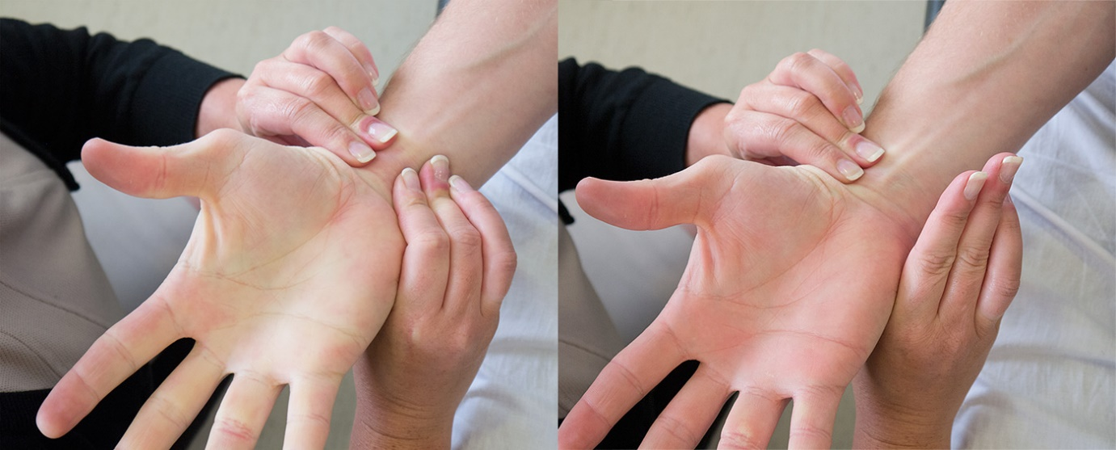
- Introduce yourself
- Identify patient
- Explain procedure- ‘today I need to do a blood test which tells us about O2 levels in your blood. This is a bit different to blood tests you might have had before- it is taken from artery and not vein and also it is taken from your wrist and not further up your arm. It might be a bit painful but I’ll try and be as gentle and quick as possible. Also we will have to press on it for a lot longer afterwards too.’
- Gain consent
- Perform Allen’s test- ‘I’ll do this to check the blood supply to your hand before we start. This was also check where I want to go in i.e. where there is good pulse in the arm’
- Gather equipment
- Wash hands with alc gel
- Dons gloves/apron
- Open equipment aseptically, prepare syringe and collect sharps bin
- The ABG
  - Identify site and check for CI e.g. broken skin, no surgery on that arm? Preferred arm? No swelling or fistula in that arm?
  - Clean skin and dry
  - Punctures the radial artery at either 45 or 90 degrees and slowly advances the needle until it is sited intra-arterial (i.e. until you get flashback)
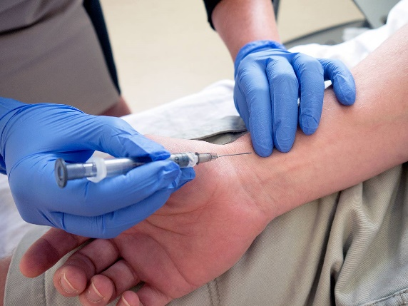
  - Allows the syringe to fill with blood.
  - Carefully withdraws needle and applies firm pressure to the puncture site
  - Checks allergy status and secures cotton wool with tape
  - Asks the patient to press firmly for a minimum of five minutes
  - Ensures that air bubbles are expelled from the syringe and caps the sample
  - Rolls or inverts the syringe immediately to mix contents with heparin
  - States “I would analyse this sample immediately, or if there is any delay, I would put the sample in ice
  - Dispose of sharp
- Check patient is ok
- Document results in notes- inc conc of flow rate of inspired O2, site used, result of Allen’s test, any complications, results of blood gas test etc.

Spirometry
You need to explain to the patient:
- What is spirometry?
  - Spirometry is a common lung function test which looks at how well your lungs are working that is how well you can breathe in and out. Breathing in and out can be affected by lung diseases such as asthma, chronic obstructive pulmonary disease, pulmonary fibrosis and cystic fibrosis. Spirometry is also used to monitor the severity of these lung conditions, and their response to treatment.
- Next, you need to teach the patient how to perform a spirometry.
  - A spirometer has a mouthpiece that you use to blow into the device. You will need to blow into a spirometer and will be given your results at the end of the procedure. Spirometry can help to tell whether if their breathing is obstructed by narrowing of the bronchial tubes as found in asthma or chronic obstructive pulmonary disease.
- You should demonstrate the technique yourself for the patient and then ask the patient to perform to check their understanding. The patient only needs to perform once during the DOCSS assessment.

- Wash hands with alc gel
- Gather equipment
- Introduce yourself
- Identify patient
- Explain procedure – ‘this is the machine here and I’m going to connect a clean mouthpiece to the machine. I will then enter you height and weight. This can show us how your lungs are working. I’ll show you myself and then I’ll let you have a go!’
- ‘I would record patients sex/age/height’
- Demonstrates technique correctly to the patient, including: Sitting upright, taking a deep breath, forming a tight seal around the mouthpiece, blowing out as hard and fast as possible until there is nothing left to expel
- Change mouthpiece.
- Check patient’s technique. Make them repeat twice more- resting for at least 30s between (patient only needs to do once). Would normally record highest values out of 3 attempts
- Check patient is ok
- State- would document procedure with a print out and put results in medical notes
Administer O2
See Minerva clinical skills section for details about when to administer and when not to administer O2. Other factors affecting O2 delivery etc.

Select the most appropriate equipment to administer oxygen to this patient, prescribe the oxygen on the prescription sheet provided and commence the oxygen therapy on the manikin.
Answer these 2 questions;
- Q1) What two things would you do to monitor this patient’s response?
  - A. Monitor oxygen saturation levels with pulse oximetry and
  - B. Repeat the arterial blood gas analysis within one hour
- Q2) What range of oxygen saturation would you ideally aim to achieve?
  - 88% – 92%
Administering oxygen;
- Washes hands with alcohol gel
- Introduce myself
- Identifies patient correctly
- ‘I’m here today to give you some O2 to try and reduce your breathlessness, I will also try and raise O2 levels in the blood because they are just a little bit low.’
- Selects Venturi mask
- Identifies correct valve- the correct oxygen percentage (accept 24% (blue) OR 28% (white) as correct) (the white bit that attaches to the mask)
- Identifies correct oxygen flow rate- the correct flow rate for the valve they have selected (24% = 2 l/min; 28% = 4l/min). (the ball thing on the wall)
- Prescribes oxygen correctly on the prescription chart
- Connect tubing to oxygen source and turn it on
- Check patency/flow before applying mask to patient.
- Make sure there is a snug fit for mask/apply it correctly
- Check patients welfare
- ‘I would document the procedure in the patients notes’

